MINISTRY OF EDUCATION AND TRAINING

FPT UNIVERSITY
Capstone Project Document
MusicLounge — Live-Music Venue Ticketing, Livestream & Donation Platform

GSU26SE68
Group Members | Hà Đông Hải — SE151247  Nguyễn Quang Anh Khoa — SE180654  Huỳnh Trung Nhiên — SE173168  Nguyễn Huy Phúc — SE161932
Supervisor | Nguyễn Trọng Tài
Ext Supervisor
Capstone Project code | SU26SE039

Table of Contents

Acknowledgement 4
Definition and Acronyms 4
I. Project Introduction 5
1. Overview 5
2. Product Background 6
3. Existing Systems 6
4. Business Opportunity 7
5. Software Product Vision 7
6. Project Scope & Limitations 8
II. Project Management Plan 10
1. Overview 10
2. Management Approach 15
3. Project Deliverables 16
4. Responsibility Assignments 17
5. Project Communications 18
6. Configuration Management 18
III. Software Requirement Specification 20
1. Product Overview 20
2. User Requirements 22
3. Functional Requirements 31
4. Non-Functional Requirements 42
5. Requirement Appendix 44
IV. Software Design Description 47
1. System Design 47
2. Database Design 52
3. Detailed Design 52
V. Software Testing Documentation 56
1. Scope of Testing 56
2. Test Strategy 57
3. Test Plan 59
4. Test Cases 61
5. Test Reports 62
VI. Release Package & User Guides 64
1. Deliverable Package 64
2. Installation Guides 64
3. User Manual 67

Acknowledgement
We would like to thank our supervisor, Nguyễn Trọng Tài, for the guidance and the direct, practical feedback that shaped this project at every milestone — particularly for pressing us on the difference between a system that demonstrates well and one that would survive real use.
We also thank the lecturers of the Software Engineering programme at FPT University, whose courses in software architecture, database design, testing and project management gave us the foundations this work builds on.
Finally, we thank the small live-music venues whose day-to-day practice this platform is modelled on. Understanding how they really sell tickets, run a night and pay performers is what kept the design honest.

Definition and Acronyms
Acronym / Term | Definition
API | Application Programming Interface — the contract every client application calls.
ASVS | Application Security Verification Standard, published by OWASP; used here as the security checklist.
CDN | Content Delivery Network — edge caching used to serve images without loading the API.
CI/CD | Continuous Integration and Continuous Deployment — the automated build, test and release pipeline.
CQRS | Command Query Responsibility Segregation — the pattern separating write commands from read queries.
Crow's-foot | The entity-relationship notation used in this report to express cardinality.
DTO | Data Transfer Object — the shape returned to a client, distinct from the stored entity.
End-to-end (E2E) | A test that drives a complete journey across frontend, API and database together.
Entity | A business object persisted as a database table.
Golden path | The main successful route an actor takes through a feature, used as the acceptance scenario.
Hold | A temporary reservation of ticket capacity taken before payment and released if unpaid.
IPN | Instant Payment Notification — the payment gateway's server-to-server confirmation callback.
Ledger (double-entry) | Accounting record in which every transaction posts balancing debit and credit lines.
Lounge / Venue | A physical live-music venue registered on the platform.
OWASP | Open Worldwide Application Security Project — the source of the security standard applied.
Performer | An artist appearing in a show's line-up; a catalogue record, not a login.
Settlement | A scheduled payout of a venue's share of ticket revenue, released in two tranches.
Show | One concrete performance event at a venue on a given evening.
SLA | Service Level Agreement — here, the deadline within which a review or response must happen.
Surface | One of the five client applications through which the platform is used.
Tier | A priced category of ticket access for a show.
UAT | User Acceptance Testing — manual walkthrough of each actor's golden path before release.
UML | Unified Modeling Language — the notation used for the diagrams in this report.
WCAG | Web Content Accessibility Guidelines — the accessibility standard applied to the web surfaces.

I. Project Introduction

1. Overview

1.1 Project Information
• Project name: MusicLounge — Live-Music Venue Ticketing, Livestream & Donation Platform
• Project code: SU26SE039
• Group name: GSU26SE68
• Software type: Web + Native Mobile, over one shared REST/SignalR API — five client surfaces (Audience Website, Audience Mobile F&B app, Owner Web Dashboard, Staff Mobile app, Admin Web Console)
• Duration: 20/05/2026 – 31/08/2026 (15 weeks)

1.2 Project Team
Full Name | Role | Email | Mobile
Nguyễn Trọng Tài | Supervisor | taint@fpt.edu.vn | 0903346184
Hà Đông Hải | Leader | haihdse151247@fpt.edu.vn | 0779956198
Huỳnh Trung Nhiên | Member | NhienHTSE173168@fpt.edu.vn | 0365960121
Nguyễn Quang Anh Khoa | Member | KhoaNQASE180654@fpt.edu.vn | 0367186849
Nguyễn Huy Phúc | Member | PhucNHSE161932@fpt.edu.vn | 0817106584

2. Product Background
Demand for live music in small, intimate rooms — music lounges, acoustic cafés, “phòng trà” — has been rising in Vietnam, particularly among younger audiences. The venues that serve that demand are small businesses running a different show most nights of the week, and they run today on a patchwork of manual processes and disconnected tools.
Door sales are cash and paper. A venue that wants to sell online falls back on a general event-ticketing platform designed around a single fixed showtime, which fits a cinema or a stadium concert far better than a lounge where a ticket is really valid for the whole evening, where walk-in sales continue after the music has started, and where the owner may price by time slot rather than by seat.
Livestreaming a show — increasingly common as a way to reach an audience beyond the room's capacity — typically runs on a general streaming platform with no way to limit viewing to genuine ticket holders. Tips that audience members want to give a performer happen informally, as cash at the door or an ad-hoc bank transfer, with no shared record of what was promised, collected or actually paid out, and no transparency to the performer about what the venue collected on their behalf.
MusicLounge replaces that patchwork with one platform built around how a small live-music venue actually operates.

3. Existing Systems
Three existing products, each covering part of what MusicLounge brings together.

3.1 Ticketbox (ticketbox.vn)
• Vietnam's largest general-purpose event ticketing platform, used for concerts, conferences and festivals nationwide.
• Actors: event organiser, buyer, platform (payment processing and ticket delivery).
• Features: online sales with QR entry, seat and zone selection, organiser dashboards, several payment methods.
• Pros: strong brand recognition and buyer trust in Vietnam, mature payment integration, handles large one-off events well.
• Cons for this segment: built around a single fixed-showtime event rather than a venue running a different show most nights; no livestream, no performer tipping, no in-venue food and drink ordering; and no recurring per-venue tooling — seating zones, staff, a subscription relationship — because each event is treated as a standalone listing.

3.2 Twitch + Streamlabs
• The dominant global pairing for live-streamed content with real-time viewer donations: Twitch for the stream, Streamlabs for the on-stream donation alert overlay.
• Actors: streamer, viewer, platform.
• Features: live video with chat, real-time donation alerts, subscription-based creator monetisation.
• Pros: an extremely mature real-time tipping experience, and a pattern audiences already recognise.
• Cons for this segment: a general content platform with no tie to a physical venue or a specific in-person show — no ticketing, no door to check a ticket at, no food and drink ordering; and a donation goes straight to the individual streamer's own account with no venue-level acknowledgement, settlement or commission step, which does not match a relationship where the venue is financially and legally the intermediary handling money on the performer's behalf.

3.3 Veeps (veeps.com)
• A ticketed livestream platform for touring artists, now owned by Live Nation. Its hybrid mode — livestreaming a show while it plays to an in-person audience — is the closest real-world precedent to MusicLounge's own model.
• Actors: artist, viewer, platform, and in the hybrid programme the partner venue supplying the room.
• Features: pay-per-view livestream tickets or an all-access subscription, live chat, VIP add-ons, and an on-demand replay catalogue.
• Pros: a proven hybrid concept, and artist-friendly economics — the full ticket price goes to the artist and the platform takes a flat service fee.
• Cons for this segment: built for touring acts at large venues rather than a neighbourhood lounge — no seating-zone, walk-in or box-office tooling, and no food and drink ordering; its donation feature is a fixed charity option attached to the ticket rather than real-time tipping; and money flows from ticket to artist directly, with no venue-side settlement step.

4. Business Opportunity
Among the platforms most commonly used for this space — a general ticketing platform (§3.1), a general livestream-and-tipping platform (§3.2), and the closest hybrid precedent (§3.3) — none brings together the four things a small Vietnamese live-music venue needs at once: ticketing that matches whole-evening validity and continuing walk-in sales rather than a fixed showtime; a livestream limited to genuine ticket holders; a transparent, auditable path from an audience member's tip to the performer who earned it; and the in-venue operational tools — food and drink ordering, door check-in, counter sales — that staff need while a show is running.
That combination is the opportunity. A platform built for the small live-music-venue segment, rather than adapted down from a stadium-concert or general-streaming product, can serve a segment that existing ticketing and streaming platforms address only in part.

5. Software Product Vision
For independent live-music venue owners in Vietnam who want to sell tickets, stream their shows and pay performers transparently without stitching together three disconnected products, and for the audiences who attend or watch those shows,
the MusicLounge platform is a ticketing, livestream and donation marketplace
that lets a venue sell both online and walk-in tickets on its own real terms, limit a livestream to genuine ticket holders, and route audience tips to performers through an auditable payout pipeline — while an audience member discovers shows, buys a ticket, watches from home when they cannot attend, and tips a performer in real time, all from one account.
Unlike a general-purpose event-ticketing platform, which assumes a fixed showtime and offers neither livestreaming nor tipping, and unlike a general livestream platform, which has no ticketing, no venue relationship and no in-person operational tools, MusicLounge is built around the specific operating pattern of a small venue running a different show most nights.

6. Project Scope & Limitations
What the platform delivers is listed in §6.1; what it deliberately does not attempt is listed in §6.2, so expectations are set on both sides.

6.1 Major Features
Each feature below is traceable to the use cases in Report 3 §2.2 and to the screens catalogued in Report 3 §3.1.
6.1 Functional Requirements
FE-01: Account and identity — Self-service registration for Audience and Owner, email OTP and phone verification, Google sign-in, profile and identity-document management, and self-service export or permanent erasure of one's own personal data. One identity works across all five client surfaces.
FE-02: Venue setup — Venue registration with business-licence upload, profile and photo-gallery management, and a drag-and-drop seating-zone editor whose zones are reused by every show at that venue.
FE-03: 360° virtual venue tour — The Owner uploads a finished panorama or several ordinary room photos that the imaging microservice stitches automatically, then places navigation and information hotspots. Audiences explore the finished tour from the venue page.
FE-04: Venue approval — An Admin review queue that must approve a venue before it is publicly listed or may publish any show.
FE-05: Show management — A creation wizard with a performer line-up builder, ticket tiers, time-slot pricing, and an AI-generated or uploaded poster, covering the full lifecycle from draft through review, publication, rescheduling, format change, and cancellation.
FE-06: Content moderation — AI risk-scoring of every show and livestream, with the final decision always taken by a human Admin, under a 24-hour review deadline.
FE-07: Discovery and personalisation — Public browsing and search, show and venue pages, follow and wishlist, show ratings, and an opt-in AI-personalised recommendation feed.
FE-08: Online ticketing — Tier selection held for 15 minutes behind a visible countdown, VNPay checkout, a QR ticket, peer-to-peer transfer, and cancellation or refund requests.
FE-09: Box office and door operations — Cash walk-in sales at the counter and QR check-in at the door, both honouring whole-evening ticket validity rather than a fixed start time.
FE-10: Gated livestream — Broadcast control for the venue, with viewing limited to genuine ticket holders within a concurrent-device limit, plus real-time chat and a viewer count.
FE-11: Real-time performer donations — In-stream tipping with a public donation ticker, a transparent settled-donation feed, and an owner-acknowledgement-to-performer-payout pipeline with evidence captured at each step.
FE-12: In-venue food and drink ordering — Menu browsing, cart, and live order tracking from a native mobile app, with a kitchen and counter order board for staff.
FE-13: Payments and double-entry ledger — Every movement of money recorded as a balanced accounting journal, with two-tranche settlement payouts to venue owners and automated reconciliation against the payment gateway.
FE-14: Owner subscriptions — A plan catalogue, subscribe, renew, and cancel functions, and entitlement caps (tickets per show, AI-poster and tour-scene quotas) enforced at the point of use.
FE-15: Complaints — A channel open even to guests, filed and later looked up by reference number and phone with no account required, feeding an Admin resolution queue with deadline tracking.
FE-16: Venue penalties and appeals — Penalty issuance with evidence, Owner appeal submission, and automatic escalation or overturn when a review deadline passes.
FE-17: Admin back office — User management, refund processing, bank-account verification, taxonomy and subscription-plan management, ledger-integrity checking, platform analytics, and background-job monitoring.
FE-18: Notifications — An in-app inbox on every surface, push notifications to the mobile apps, and email and SMS for events that must reach a user while they are away from the platform.
6.2 Limitations & Exclusions
LI-01: The VNPay integration runs against the sandbox environment; there is no live production merchant relationship, consistent with this being an academic capstone rather than a commercially trading platform.
LI-02: There is no self-service or API path to create an Admin account. Every Admin exists only through a direct database provisioning step, watched by an automated drift-detection job. This is a deliberate security posture, not a missing feature.
LI-03: A Staff account may be actively assigned to exactly one venue at a time; someone genuinely working at two venues needs two accounts. This is an intentional simplification.
LI-04: Refund approval reverses the internal ledger entries and records the payout for manual transfer; it does not settle money back through the live payment provider, matching the sandbox limitation above.
LI-05: SMS delivery for one-time codes and notifications targets Vietnamese phone numbers only.
LI-06: Door check-in and counter sales have no offline mode. A dropped connection blocks the action rather than silently queuing it — an accepted trade-off against the risk of double-selling a seat.
LI-07: Bank-account verification is a manual Admin action taken after reconciling ownership outside the system; there is no banking-API integration to verify an account holder automatically.
LI-08: The two native mobile applications are distributed as signed internal review builds rather than published to the public App Store and Google Play, which is a capstone-scope decision rather than a technical constraint.
LI-09: The user interface ships in Vietnamese only; no language switch is provided, because the platform targets the Vietnamese market exclusively.

II. Project Management Plan

1. Overview

1.1 Scope & Estimation
Every deliverable of the platform is broken down below and estimated in man-days. Each leaf item is rated Simple, Medium or Complex against how much of it is new logic rather than a repeat of an established pattern. Group rows carry no estimate of their own; the total is the sum of the leaves.
# | WBS Item | Complexity | Est. Effort (man-days)
1 | Auth & Account Management
1.1 | Register / verify / login, Google OAuth, JWT + policy-based authorization | Complex | 12
1.2 | Forgot & reset password, profile edit, identity-document upload | Medium | 6
1.3 | Personal-data export and erasure (anonymise in place) | Medium | 5
2 | Venue Management
2.1 | Venue CRUD, business-licence and photo upload | Medium | 6
2.2 | Seating-zone drag-and-drop editor (2D/3D) | Complex | 10
2.3 | 360° virtual tour: scene and hotspot editor, auto-stitch integration | Complex | 14
2.4 | Staff assignment, venue gallery, custom criteria | Medium | 7
3 | Venue Approval & Content Moderation
3.1 | Venue approve / reject queue | Simple | 3
3.2 | AI-assisted show and livestream moderation queue | Complex | 10
4 | Show Management
4.1 | Show CRUD and performer line-up builder | Medium | 8
4.2 | Show lifecycle: submit, publish, reschedule, change format, cancel | Complex | 10
4.3 | Ticket tiers, pricing windows, AI poster generation | Medium | 8
4.4 | Legal permit and royalty declaration | Simple | 2
5 | Ticketing
5.1 | Ticket hold (15 minutes) and quota management | Medium | 6
5.2 | VNPay payment integration and QR generation | Complex | 10
5.3 | Transfer, cancellation and refund-request workflow | Medium | 8
5.4 | Walk-in sale and door check-in | Medium | 7
6 | Livestream
6.1 | Provider integration (Mux / Cloudflare) and broadcast start / end | Complex | 12
6.2 | Access-gated viewing room, chat, viewer count | Complex | 12
6.3 | Concurrent-device session limiting | Medium | 5
7 | Donation & Financial Ledger
7.1 | Donate flow, owner acknowledgement, performer payout | Complex | 11
7.2 | Double-entry ledger and reconciliation job | Complex | 12
7.3 | Two-tranche settlement, public donation ticker and feed | Complex | 11
8 | F&B Ordering
8.1 | Menu CRUD and mobile ordering flow | Medium | 6
8.2 | Staff order board with status progression | Simple | 4
9 | Subscription & Billing
9.1 | Plan CRUD (Admin); subscribe, renew, cancel (Owner) | Medium | 7
10 | Complaints & Venue Penalties
10.1 | Complaint filing, lookup and resolution, including the guest path | Medium | 7
10.2 | Penalty issue, appeal and automatic overturn workflow | Medium | 7
11 | Recommendation & Personalisation
11.1 | Behaviour logging, event scoring, hybrid recommender | Complex | 12
11.2 | Follow, wishlist and rating | Simple | 4
12 | Notifications
12.1 | Push integration, notification inbox, SMS integration | Medium | 8
13 | Admin Back-Office
13.1 | User management, bank-account verification, ledger-integrity check | Medium | 8
13.2 | Taxonomy and subscription-plan management, platform analytics | Medium | 6
14 | Backend Cross-Cutting Work
14.1 | Clean Architecture scaffold, CQRS pipeline, repository and unit of work | Complex | 10
14.2 | Background jobs for SLA, expiry, settlement and security monitoring | Complex | 14
14.3 | Security hardening and legal/compliance mapping | Complex | 12
14.4 | Backend test suite | Complex | 15
15 | Frontend Implementation
15.1 | Auth and account screens across all surfaces | Medium | 10
15.2 | Venue setup, seating-zone editor, 360° tour builder | Complex | 18
15.3 | Venue approval and moderation review queues | Medium | 6
15.4 | Show wizard, line-up builder, ticket tier and poster screens | Complex | 10
15.5 | Browse, purchase, hold countdown, QR ticket, walk-in point of sale | Complex | 14
15.6 | Livestream viewing room, chat and broadcast control | Complex | 12
15.7 | Donation widget, public ticker, payout and ledger views | Medium | 9
15.8 | F&B ordering app and staff order board | Medium | 8
15.9 | Subscription plan and billing screens | Medium | 5
15.10 | Complaint and penalty screens | Medium | 6
15.11 | Recommendation feed, follow, wishlist and rating | Medium | 5
15.12 | Notification inbox and push permission handling | Simple | 4
15.13 | Admin back-office screens and analytics dashboard | Medium | 10
15.14 | Design system, routing and auth guards, API client, responsive behaviour | Complex | 12
16 | UI/UX Design
16.1 | Design system and style guide | Medium | 4
16.2 | Per-surface design briefs, view catalogue and screen-flow diagrams | Complex | 8
16.3 | High-fidelity mock-ups per view | Complex | 10
17 | Deployment & Hosting
17.1 | Azure provisioning, CI/CD pipeline, domain and TLS | Medium | 6
18 | Documentation
18.1 | Domain and architecture documentation | Medium | 6
18.2 | SEP490 report set | Complex | 10
 | Total Estimated Effort (man-days) |  | 488

1.2 Project Objectives
Scope objective — deliver a working, multi-surface platform that a review committee can exercise end to end across all 4 roles (Audience, Owner, Staff, Admin) on a deployed environment: the backend API, all five client surfaces, the imaging microservice and the Azure hosting they run on.
Time objective — fit the work breakdown above inside the project window (20/05/2026 – 31/08/2026, about 15 weeks), sequenced so that every domain's happy path is functional well before the final weeks, leaving the last two to three weeks for hardening, security and accessibility review, and documentation rather than first-time feature work.
Cost objective — effort is a fixed team-capacity budget rather than a monetary one. The work breakdown sums to 488 man-days across backend, frontend, design, deployment and documentation, delivered by the 4-member team named in Report 1 §1.2.
Quality objective — the targets below are checked at each milestone rather than only at the end.
# | Testing Stage | Coverage | Target | Notes
1 | Code review | 100% of pull requests | No unreviewed merge | Every change reviewed against the project's own review checklist before merge.
2 | Unit test | Domain and Application logic; frontend components | All documented business rules covered | Runs with no database and no network, so a broken rule is caught before integration.
3 | Integration test | Every handler that touches the database | 0 known-broken at release | Runs against SQLite in CI and against real SQL Server before each milestone.
4 | End-to-end test | Each actor's golden path across surfaces | 0 failing scenarios | Browser and device automation against the deployed staging environment.
5 | Security & accessibility | OWASP ASVS 5.0.0; WCAG 2.2 AA | 0 open Blocker or Critical | Reviewed before the release gate.

1.3 Project Risks
# | Risk Description | Impact | Likelihood | Response Plan
1 | The payment gateway behaves differently in production than in the sandbox, particularly around callback timing and retries. | High | Medium | Build the callback handler to be idempotent and safe against duplicate or out-of-order delivery regardless of what the sandbox happens to do, rather than coding to observed sandbox behaviour.
2 | The CI database engine (SQLite) and the production engine (SQL Server) diverge on cascade rules and enum-string columns, so a fully green CI run is not proof of correctness. | High | High | Already materialised once: a real SQL-Server-only defect passed a green SQLite suite. The full suite is re-run against a real SQL Server instance before every milestone release.
3 | Third-party AI dependency for moderation, poster generation and recommendation scoring — an outage, quota exhaustion or policy change is outside the team's control. | Medium | Medium | Every AI call degrades gracefully to a neutral result rather than blocking the request, and poster generation has a second provider behind the same interface.
4 | The panorama-stitching feature depends on native image-processing binaries that behave differently across machines. | Medium | Medium | Kept as a separate containerised microservice so a stitching failure degrades one feature instead of the whole API.
5 | Frontend work is concentrated in the second half of the schedule, so any slip in design handoff or screen wiring compresses the remaining buffer. | High | Medium | Track frontend progress as its own burndown, and prioritise screens by role-criticality (ticket purchase, venue and show management) over lower-value surfaces if time runs short.
6 | Only a small number of Admin accounts exist and there is no self-service path to create one, so losing Admin access blocks a large surface of testing. | Medium | Low | Document the provisioning procedure and keep at least one known-good Admin credential recorded outside any single member's personal notes.
7 | Livestream infrastructure is a paid third-party service; exhausting credit close to a demo would break the most visible feature. | Medium | Low | Confirm provider account status and quota headroom explicitly ahead of each demo.
8 | Team familiarity with the architecture and the frontend stack varies, so a change can quietly break a layering rule or a shared convention. | Medium | Medium | Addressed by the training plan in §2.3 and by mandatory review against the project's conventions before merge.
9 | Scope creep — the domain offers more genuinely useful features than the schedule can absorb. | Medium | Medium | The work breakdown in §1.1 is the scope contract; new requests are logged and prioritised against it rather than added ad hoc.

2. Management Approach
The team works in weekly sprints aligned to the supervisor check-in cadence, with quality practices applied continuously rather than saved for the end.

2.1 Project Process
Scrum with one-week sprints: planning at the start of the week, a working demo at the end of it, and a short retrospective before the next planning session. The work breakdown in §1.1 is the product backlog, and each leaf item is split into one to three sprint tasks at planning time.
Sprints 1–2: project scaffold, CI pipeline and database migrations; backend authentication; design system and per-surface design briefs. Sprints 3–6: backend venue, show and ticketing — the core marketplace loop — in parallel with the frontend authentication and venue screens. Sprints 7–9: backend livestream, donation and ledger, the most architecturally demanding area, sequenced after the core loop is stable; frontend show and ticketing screens alongside. Sprints 10–11: backend F&B, subscription, complaints and admin back-office; frontend livestream and donation screens. Sprints 12–13: remaining frontend screens and the mobile applications; cross-cutting hardening. Sprints 14–15: Azure deployment, full regression against real SQL Server, user acceptance testing, demo rehearsal and documentation.

2.2 Quality Management
Five practices, applied every sprint rather than at the end of the project:
• Defect prevention — a fixed set of conventions per tier, enforced at review rather than discovered in testing: on the backend, data access only through the repository and unit of work, no direct database access from the API layer, and a validator for every command; on the frontend, shared design-system components instead of one-off markup, server state owned by the query library rather than hand-rolled effects, and no screen shipped without its loading, empty and error states designed.
• Reviewing — every pull request reviewed against the documented conventions before merge, with no direct pushes to the main branch. A change spanning tiers is raised as linked pull requests reviewed together, so an API contract and its consumer never merge out of step.
• Unit testing — backend domain and application logic tested with no database, and frontend components tested in isolation against a mocked API, so a broken rule or a broken screen state is caught before integration testing runs.
• Integration testing — real handler-to-database round trips, run in CI for speed and again against a real SQL Server instance before every milestone, to catch the class of defect the CI engine cannot reproduce.
• System testing — automated end-to-end journeys plus manual walkthroughs of each actor's golden path against the deployed environment, together with a security pass against OWASP ASVS 5.0.0, an accessibility pass against WCAG 2.2 Level AA, and a load pass against realistic peak shapes.

2.3 Training Plan
Training Area | Participants | When, Duration | Waiver Criteria
Clean Architecture and CQRS | Any member new to the pattern | Sprint 1, ~1 day | Waived with prior project experience in the pattern
EF Core and SQL Server: migrations, indexing, transactions | Any member new to EF Core | Sprints 1–2, ~1 day | Waived with prior EF Core project experience
React, TypeScript and Tailwind CSS | Any member new to the frontend stack | Sprints 2–3, ~1 day | Waived with prior React and TypeScript experience
React Native and mobile build tooling | Members building the two mobile apps | Sprint 10, ~0.5 day | Waived with prior React Native experience
Git and pull-request workflow | All members | Sprint 1, ~0.5 day | Mandatory
Azure deployment and CI/CD | Members owning deployment | Sprint 13, ~0.5 day | Mandatory for the task owners
OWASP ASVS 5.0.0 and WCAG 2.2 basics | Members owning the security and accessibility passes | Before Sprint 13 | Mandatory for the task owners

3. Project Deliverables
# | Deliverable | Due | Notes
1 | Product backlog and work breakdown | Sprint 1, revised each sprint | The scope contract for the project (§1.1).
2 | Backend API source code | End of project | Clean Architecture solution.
3 | Frontend source code — three web applications | End of project | Audience Website, Owner Dashboard, Admin Console.
4 | Frontend source code — two mobile applications | End of project | Staff Mobile and Audience F&B, as signed review builds.
5 | Panorama-stitching microservice | End of project | Containerised imaging service.
6 | Database migration scripts | End of project | Code-First migrations; no hand-written DDL.
7 | Deployed platform on Azure | End of project | Reachable URLs and installable mobile builds for the review committee.
8 | Reports 1–7 | End of project | The SEP490 document set.
9 | Test evidence | End of project | Test case workbooks and the executed test report.
10 | Defect list | Continuous | Tracked throughout; summarised in Report 5.
11 | Presentation slide deck | Demo date | —

4. Responsibility Assignments
D — Do · R — Review · S — Support · I — Informed · blank — not involved. Each row names exactly one owner so accountability is never split, and every deliverable that leaves the team has a named reviewer.
Responsibility | Hải (Leader) | Nhiên | Khoa | Phúc
Project planning and tracking | D | S | S | S
Requirements analysis and specification (Reports 1 and 3) | R | D | S | S
UI/UX design system and per-surface design briefs | S | D | R | I
Solution architecture and design document (Report 4) | D | R | S | S
Backend — platform scaffold and shared infrastructure | D | S | S | R
Backend — auth, venue, show, ticketing | R | D | S | S
Backend — livestream, donation, payment and ledger | D | S | R | S
Backend — F&B, subscription, complaints, admin back-office | R | S | D | S
Backend — background jobs and security hardening | R | I | S | D
Frontend — Audience Website | S | D | R | I
Frontend — Owner Web Dashboard | R | S | D | S
Frontend — Admin Web Console | S | R | S | D
Frontend — Staff and Audience mobile applications | D | S | S | R
Test design, automation and execution (Report 5) | R | S | S | D
Azure deployment, CI/CD and environment configuration | D | I | S | R
Documentation and user guides (Report 6) | S | R | I | D
Final integration, Report 7 and demo rehearsal | D | S | S | S

5. Project Communications
Communication Item | Who / Target | Purpose | When, Frequency | Type, Tool
Sprint planning | Whole team and supervisor | Agree the sprint's scope and acceptance criteria | Weekly, start of sprint | Meeting, in person or online
Sprint demo and retrospective | Whole team and supervisor | Show working software; review what did and did not go well | Weekly, end of sprint | Meeting with a running instance
Daily sync | Whole team | Surface blockers early | Daily, about 15 minutes | Chat channel or short call
Code review | Author and reviewer | Catch defects and convention drift before merge | Per pull request | Pull-request comments
Supervisor check-in | Leader and supervisor | Escalate risks, confirm scope decisions | At least fortnightly | Email or scheduled meeting
Defect reporting | Whole team | Log and triage a found defect | As found | Issue tracker

6. Configuration Management

6.1 Document Management
All narrative documentation lives in the repository in Markdown, version-controlled alongside the code it describes, so a documentation change and the code change it documents land in the same review. A separate wiki or shared drive drifts out of sync with the code far more easily.
The seven formal report documents are generated from that same source into the official templates rather than hand-edited, so a scope or design change can be reflected by rebuilding them instead of manually patching each file — which is what previously let the reports drift apart from one another.
Every substantive change is recorded in that document's own Record of Changes table, so a reader opening only the document still sees its change history without consulting the repository.

6.2 Source Code Management
Git hosted on GitHub, across the platform's repositories: the backend API, the client applications and the imaging microservice. Trunk-based development off a single main branch in each, with short-lived feature branches per work-breakdown task merged through a pull request.
Every pull request needs at least one review before merge, and the CI pipeline runs the relevant test suite on every request with merge blocked on a red build. Database schema changes are Code-First migrations committed alongside the entity change that caused them, so there is no hand-written DDL and no schema drift between environments.

6.3 Tools & Infrastructures
Category | Tools / Infrastructure
Backend framework | ASP.NET Core 8 (C#), Clean Architecture, MediatR (CQRS), FluentValidation, EF Core 8
Database and ORM | SQL Server 2022 / Azure SQL Database; SQLite for CI-speed integration tests
Background jobs | Hangfire — 30 job classes, 22 on recurring schedules
Real-time | SignalR — livestream chat and access gating, donation ticker
Frontend — web | React 18 + TypeScript 5 + Vite 5 + Tailwind CSS 3, TanStack Query, React Router
Frontend — mobile | React Native + TypeScript, React Navigation
UI/UX design | Shared design system and component library, driven from per-surface design briefs
Auxiliary microservice | Python 3.12 + OpenCV + Hugin (panorama stitching)
Payment | VNPay (sandbox environment)
Livestream | Mux and Cloudflare Stream, selected at runtime behind a provider factory
AI services | Gemini for moderation, poster generation and recommendation scoring; OpenAI as an alternate poster provider
Notifications | Firebase Cloud Messaging (push), SpeedSMS (SMS in Vietnam), SMTP (email)
Cloud platform | Microsoft Azure — Azure App Service (Linux), Azure SQL Database, Azure Container Apps, Azure Static Web Apps, Azure Blob Storage + CDN, Azure Key Vault, Application Insights + Azure Monitor
Source control and CI/CD | Git and GitHub with pull-request-gated GitHub Actions; build, test, then deploy to Azure on merge
Testing | xUnit and FluentAssertions (backend), Vitest and React Testing Library (web), Jest and React Native Testing Library (mobile), Playwright (end-to-end), k6 (load)
API documentation | Swagger / OpenAPI interactive documentation
Diagramming | draw.io for structural diagrams and PlantUML for behavioural diagrams, rendered to black-and-white images
Milestone timeliness — at least 90% of sprint-end milestones delivered on the date committed at sprint planning.
Allocated effort — Requirements and design 18%, coding (backend and frontend) 62%, testing 12%, documentation 8% of the 488 man-day total.

III. Software Requirement Specification

1. Product Overview
MusicLounge is a ticketing, livestream and donation platform built for small live-music venues in Vietnam. It replaces the patchwork of paper door sales, general-purpose ticketing, ungated streaming and informal cash tipping that such venues rely on today with a single system built around how they actually operate: a ticket valid for the whole evening, walk-in sales that continue after the music starts, a livestream limited to genuine ticket holders, and an auditable path from an audience member's tip to the performer who earned it.
The platform is delivered as 5 client applications over one shared REST and SignalR API, each built for one job rather than one universal app: the Audience Website (discover, buy, watch, tip, rate), the Audience Mobile app (order food and drink while seated at a venue), the Owner Web Dashboard (venue setup, shows, money), the Staff Mobile app (counter sales, door check-in, the F&B board) and the Admin Web Console (approval, moderation, refunds, complaints, monitoring).
Figure 1 shows the system boundary: who exchanges data with the platform, and in which direction. Everything inside the boundary is built by this project; everything outside is a third-party service the platform integrates with.
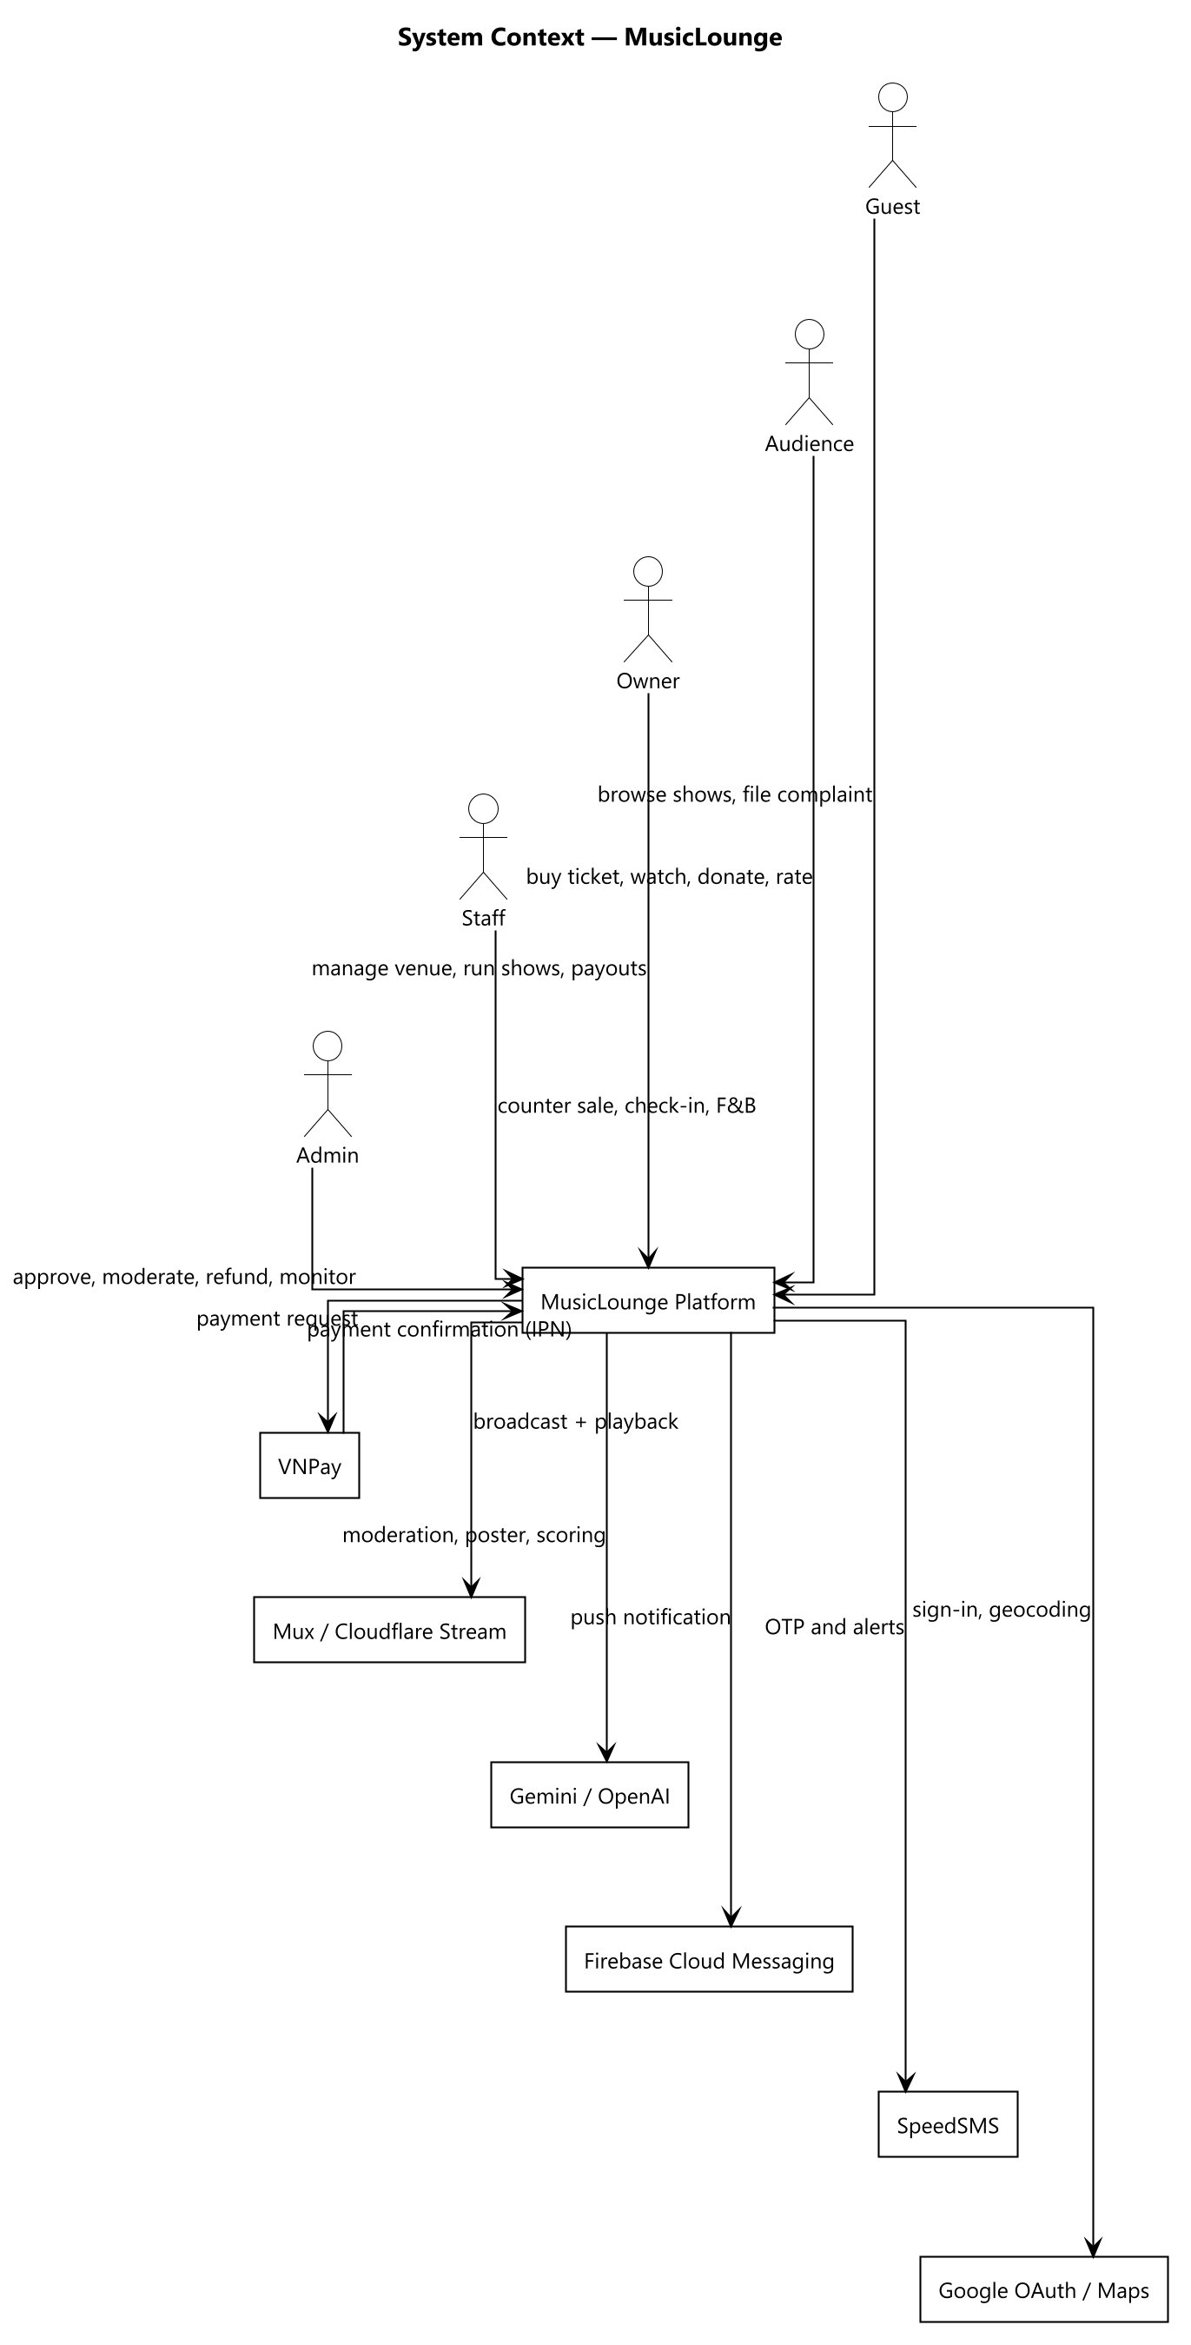
Figure 1 — System context — actors and external services around the platform boundary
Constraints and assumptions. All payments are intermediated by a licensed gateway and the platform never handles card data. The user interface is Vietnamese-only, because the platform targets the Vietnamese market. Door check-in and counter sales assume connectivity — there is no offline mode, deliberately, to avoid double-selling a seat. Administrator accounts are provisioned directly by an operator; there is no self-service path to become one.

2. User Requirements

2.1 Actors
The platform has 6 actors. Four of them (4) hold accounts and sign in; Guest is the unauthenticated visitor, and Performer is a catalogue record maintained by an Owner rather than a login of its own.
# | Actor | Description
1 | Guest | An unauthenticated visitor. Can browse published shows and venues, explore a 360° tour, and file a complaint with a reference number — but cannot buy, watch or donate.
2 | Audience | A registered customer. Discovers shows, buys and manages tickets, watches gated livestreams, tips performers, orders food and drink in-venue, rates shows and files complaints.
3 | Owner | Runs one or more venues. Registers the venue, manages seating zones and the 360° tour, creates and operates shows, handles donations and views earnings. Pays a platform subscription.
4 | Staff | Assigned by an Owner to exactly one venue. Sells walk-in tickets at the counter, checks tickets at the door, works the F&B order board and starts or ends a broadcast.
5 | Admin | Platform operator. Approves venues, moderates shows and livestreams, processes refunds, verifies bank accounts, issues penalties, resolves complaints and monitors the ledger. Provisioned directly in the database — there is deliberately no self-service path.
6 | Performer | Appears in a show's line-up and receives donations. Has a public profile and a payout bank account but no login of its own — an Owner maintains the record on their behalf.

2.2 Use Cases
109 use cases across 11 feature areas. Each is named as a verb phrase from the actor's point of view and describes an interaction that leaves the actor with something of value.

2.2.1 Diagram(s)
The use cases are split across two diagrams to stay legible: the public and customer-facing side, then the operator side. An actor generalisation arrow means the child actor can also do everything the parent can.
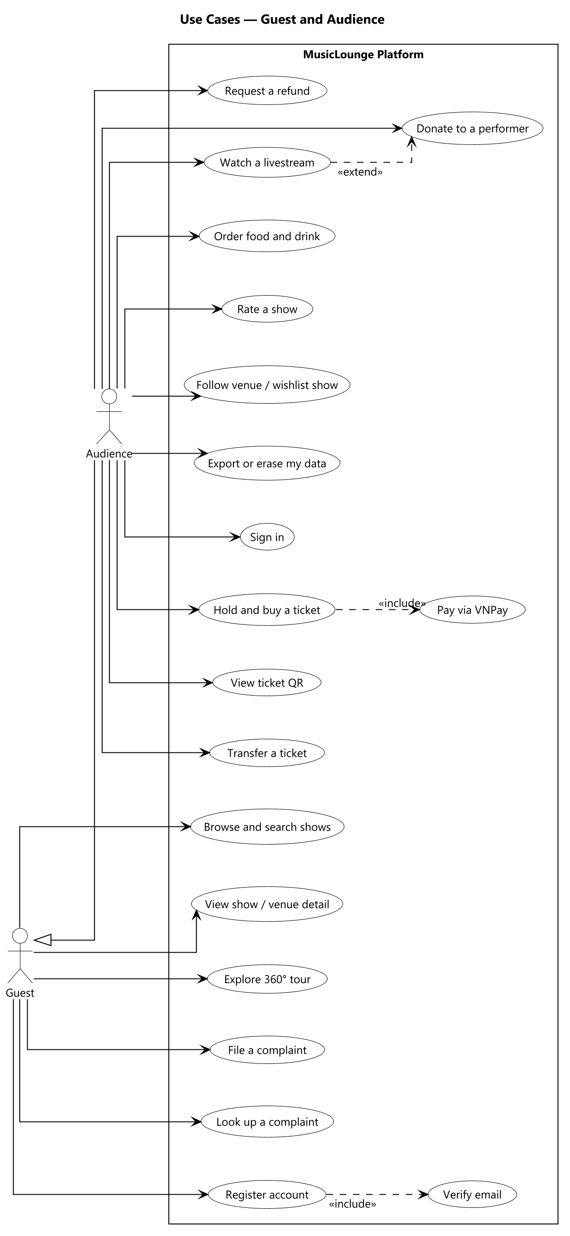
Figure 2 — Use cases — Guest and Audience
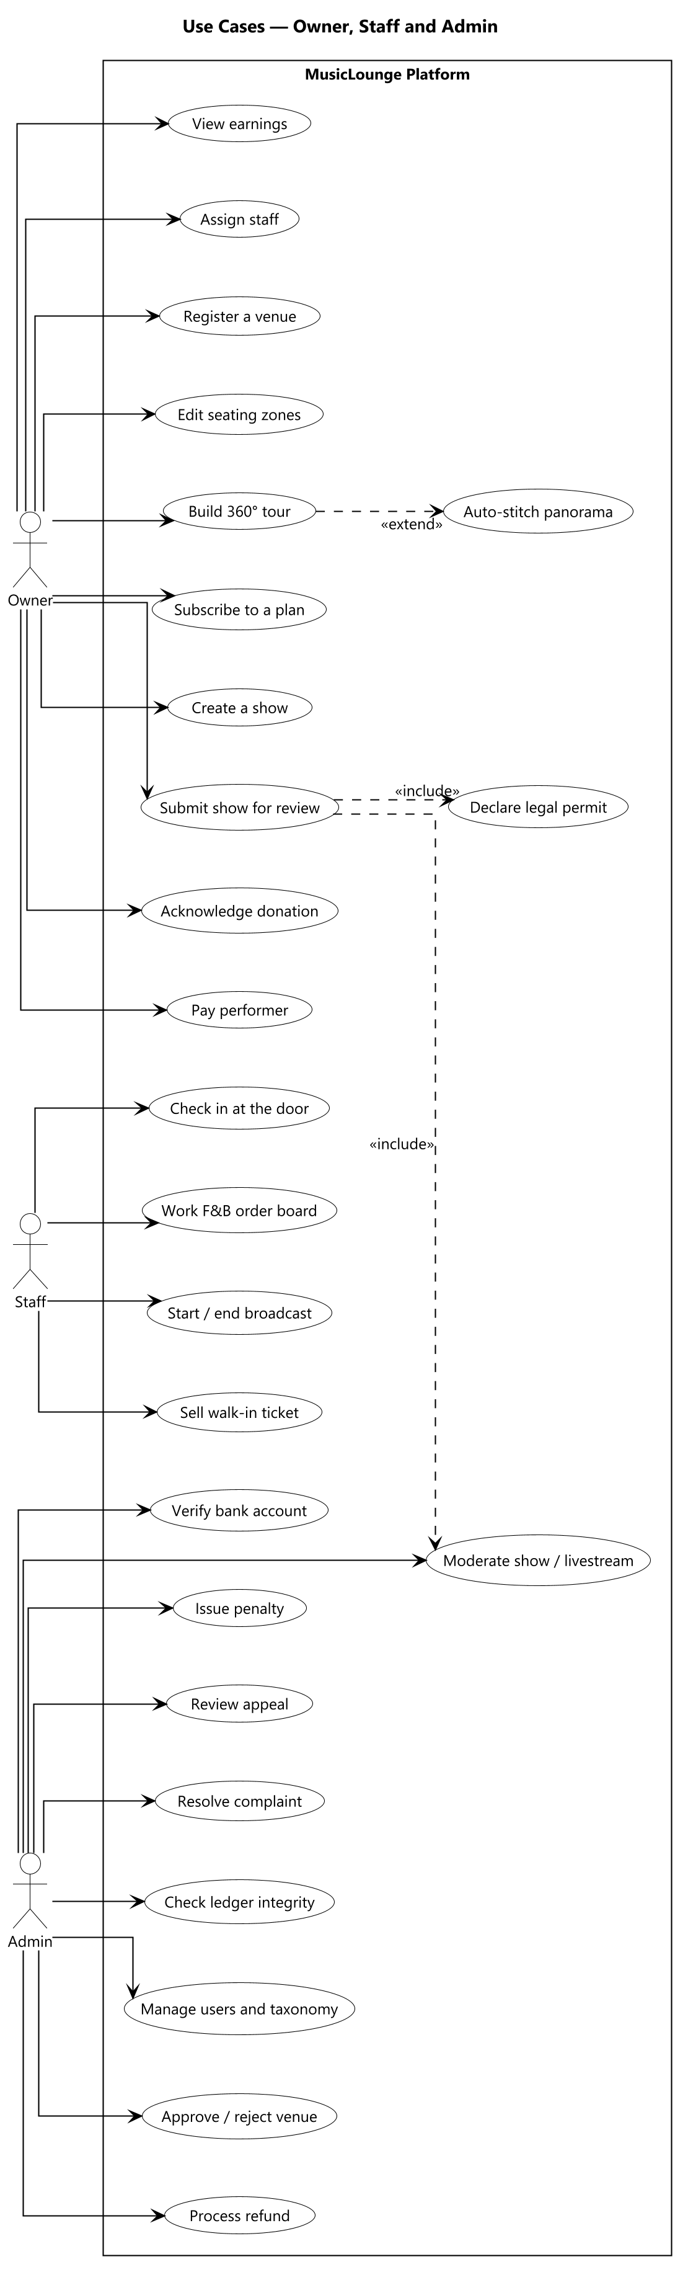
Figure 3 — Use cases — Owner, Staff and Admin

2.2.2 Descriptions
ID | Feature Area | Use Case | Actors | Description
UC-01 | Account & Identity | Register account | Guest | Create an Audience or Owner account; Staff and Admin cannot self-register.
UC-02 | Account & Identity | Verify email | Guest | Enter the emailed one-time code to activate the account and receive the first token.
UC-03 | Account & Identity | Verify phone number | Audience, Owner | Confirm a phone number by SMS code, required before certain actions.
UC-04 | Account & Identity | Sign in | Audience, Owner, Staff, Admin | Authenticate with email and password and receive a session token.
UC-05 | Account & Identity | Sign in with Google | Guest | Authenticate through Google as an alternative to a local password.
UC-06 | Account & Identity | Recover password | Guest | Request a reset link and set a new password; all existing sessions are invalidated.
UC-07 | Account & Identity | Edit profile | Audience, Owner, Staff, Admin | Update display name, contact details and avatar.
UC-08 | Account & Identity | Upload identity document | Owner | Submit identity images required before payout can be verified.
UC-09 | Account & Identity | Set AI preferences | Audience | Opt in or out of behaviour logging and personalised recommendations.
UC-10 | Account & Identity | Export my data | Audience, Owner, Staff | Download a machine-readable copy of one's own personal data.
UC-11 | Account & Identity | Erase my data | Audience, Owner, Staff | Irreversibly anonymise the account while retaining legally required financial records.
UC-12 | Account & Identity | Sign out | Audience, Owner, Staff, Admin | End the current session.
UC-13 | Discovery | Browse shows | Guest, Audience | List published shows with paging.
UC-14 | Discovery | Search and filter shows | Guest, Audience | Narrow by genre, mood, date, city or price.
UC-15 | Discovery | View show detail | Guest, Audience | See line-up, tiers, venue and availability.
UC-16 | Discovery | View venue detail | Guest, Audience | See a venue profile, gallery and upcoming shows.
UC-17 | Discovery | Explore 360° virtual tour | Guest, Audience | Navigate panorama scenes and hotspots of a venue.
UC-18 | Discovery | View performer profile | Guest, Audience | See a performer's biography, links and upcoming appearances.
UC-19 | Discovery | Follow a venue | Audience | Subscribe to a venue's updates.
UC-20 | Discovery | Add show to wishlist | Audience | Save a show for later.
UC-21 | Discovery | View personalised recommendations | Audience | See an opt-in ranked feed of suggested shows.
UC-22 | Discovery | Rate a show | Audience | Leave a star rating and comment after a show ends.
UC-23 | Ticketing | Hold tickets | Audience | Reserve a tier and quantity for a fixed countdown before payment.
UC-24 | Ticketing | Pay for a ticket | Audience | Complete payment through the gateway and receive a confirmed ticket.
UC-25 | Ticketing | Cancel a hold | Audience | Release a reservation before it expires.
UC-26 | Ticketing | View my tickets | Audience | List confirmed, used and cancelled tickets.
UC-27 | Ticketing | View ticket QR | Audience | Show the code presented at the door.
UC-28 | Ticketing | Transfer a ticket | Audience | Offer a ticket to another account; it is frozen while pending.
UC-29 | Ticketing | Accept a transferred ticket | Audience | Take ownership of a ticket offered by another account.
UC-30 | Ticketing | Cancel a ticket | Audience | Request cancellation, creating a refund request for review.
UC-31 | Ticketing | Request a refund | Audience | Ask for money back against a confirmed ticket.
UC-32 | Ticketing | Sell a walk-in ticket | Staff, Owner | Take cash at the counter and issue a confirmed ticket immediately.
UC-33 | Ticketing | Check in a ticket | Staff | Scan a code at the door and mark the ticket used.
UC-34 | Venue Management | Register a venue | Owner | Create a venue with address and business licence, pending approval.
UC-35 | Venue Management | Edit venue profile | Owner | Update description, atmosphere, contact and imagery.
UC-36 | Venue Management | Manage venue gallery | Owner | Add or remove showcase photographs.
UC-37 | Venue Management | Create seating zone | Owner | Define a named area with a real physical capacity.
UC-38 | Venue Management | Arrange seating layout | Owner | Position zones on the floor-plan image.
UC-39 | Venue Management | Upload panorama scene | Owner | Add a finished 360° image to the virtual tour.
UC-40 | Venue Management | Auto-stitch panorama | Owner | Submit several photos for the imaging service to assemble.
UC-41 | Venue Management | Place tour hotspot | Owner | Link scenes together or attach an information popup.
UC-42 | Venue Management | Define custom criteria | Owner | Add venue-specific tags used by the recommender.
UC-43 | Venue Management | Assign staff | Owner | Grant an existing account Staff access to this venue.
UC-44 | Venue Management | Deactivate staff | Owner | Revoke a staff assignment.
UC-45 | Venue Management | Register bank account | Owner | Add the payout account for venue earnings.
UC-46 | Show Management | Create a show | Owner | Draft a show with schedule, description and format.
UC-47 | Show Management | Build performer line-up | Owner | Add performers and their donation eligibility per slot.
UC-48 | Show Management | Create performer profile | Owner | Add a performer to the catalogue.
UC-49 | Show Management | Define ticket tier | Owner | Create a priced access tier with capacity.
UC-50 | Show Management | Define pricing window | Owner | Set sale start, end and channel for a tier.
UC-51 | Show Management | Generate show poster with AI | Owner | Produce a poster image within the plan quota.
UC-52 | Show Management | Upload show poster | Owner | Attach an existing image instead.
UC-53 | Show Management | Declare legal permit | Owner | Record the performance permit and royalty references.
UC-54 | Show Management | Submit show for review | Owner | Move a draft into the moderation queue.
UC-55 | Show Management | Reschedule a show | Owner | Change the date or time of a published show.
UC-56 | Show Management | Change show format | Owner | Switch between in-person and online, refunding as required.
UC-57 | Show Management | Cancel a show | Owner | Cancel and refund every confirmed ticket.
UC-58 | Livestream & Donation | Start broadcast | Owner, Staff | Open the stream for a published show.
UC-59 | Livestream & Donation | End broadcast | Owner, Staff | Close the stream normally.
UC-60 | Livestream & Donation | Watch a livestream | Audience | View a stream as a genuine ticket holder within the device limit.
UC-61 | Livestream & Donation | Send chat message | Audience | Post to the live chat, subject to rate limiting.
UC-62 | Livestream & Donation | View viewer count | Owner, Staff | See how many are currently watching.
UC-63 | Livestream & Donation | Donate to a performer | Audience | Tip a performer in the current line-up.
UC-64 | Livestream & Donation | Set donation privacy | Audience | Choose anonymity, amount visibility and message publication.
UC-65 | Livestream & Donation | View public donation ticker | Guest, Audience | See donations as they clear.
UC-66 | Livestream & Donation | View donation transparency feed | Guest, Audience | Review settled donations across the platform.
UC-67 | Livestream & Donation | Acknowledge a donation | Owner | Confirm receipt of a donation on the performer's behalf.
UC-68 | Livestream & Donation | Confirm performer payout | Owner | Record that the performer's share has been transferred, with evidence.
UC-69 | Livestream & Donation | View my donations | Audience | Track the status of tips given.
UC-70 | Livestream & Donation | Force-stop a livestream | Admin | Terminate a stream that breaches policy.
UC-71 | Food & Beverage | Manage F&B menu | Owner | Create menus and items with prices.
UC-72 | Food & Beverage | Browse menu | Audience | View the venue's menu while seated.
UC-73 | Food & Beverage | Place an F&B order | Audience | Order items to the table.
UC-74 | Food & Beverage | Track my order | Audience | Follow the order's status.
UC-75 | Food & Beverage | Advance order status | Staff | Move an order through preparing, served and paid.
UC-76 | Food & Beverage | Cancel an order | Staff | Void an order before it is paid.
UC-77 | Payments & Finance | Process gateway callback | System | Confirm or fail a payment from the gateway's server-to-server notification.
UC-78 | Payments & Finance | Post ledger journal | System | Write a balanced double-entry journal for a confirmed payment.
UC-79 | Payments & Finance | Release settlement tranche | System | Pay an owner's share on the configured schedule.
UC-80 | Payments & Finance | Reconcile with gateway | System | Compare platform records against the gateway's own.
UC-81 | Payments & Finance | View earnings | Owner | See revenue, fees and settlements for a venue.
UC-82 | Payments & Finance | Process a refund request | Admin | Approve or reject a refund, in full or in part.
UC-83 | Payments & Finance | Reverse a donation | Admin | Post a compensating journal for a donation.
UC-84 | Payments & Finance | Verify a bank account | Admin | Mark a payout account verified after off-system reconciliation.
UC-85 | Payments & Finance | Check ledger integrity | Admin | Confirm every journal balances.
UC-86 | Subscription | View subscription plans | Owner | Compare available plans and their entitlements.
UC-87 | Subscription | Subscribe to a plan | Owner | Pay for and activate a plan.
UC-88 | Subscription | Renew a subscription | Owner | Extend an active plan with a fresh payment.
UC-89 | Subscription | Cancel a subscription | Owner | End the current plan.
UC-90 | Subscription | Manage subscription plans | Admin | Create and adjust the plan catalogue.
UC-91 | Moderation & Compliance | Approve or reject a venue | Admin | Decide whether a venue may operate publicly.
UC-92 | Moderation & Compliance | Score content with AI | System | Produce a risk score and recommendation for a submission.
UC-93 | Moderation & Compliance | Review a show | Admin | Approve or reject a submitted show.
UC-94 | Moderation & Compliance | Review a livestream | Admin | Approve or reject a livestream before it may start.
UC-95 | Moderation & Compliance | Issue a venue penalty | Admin | Record a warning, suspension or ban with evidence.
UC-96 | Moderation & Compliance | Appeal a penalty | Owner | Contest a penalty within the appeal window.
UC-97 | Moderation & Compliance | Review an appeal | Admin | Uphold or overturn a contested penalty.
UC-98 | Moderation & Compliance | File a complaint | Guest, Audience | Report an issue against a ticket, show or venue.
UC-99 | Moderation & Compliance | Look up a complaint | Guest | Retrieve a complaint by reference number and phone.
UC-100 | Moderation & Compliance | Resolve a complaint | Admin | Close a complaint with an outcome and notify the complainant.
UC-101 | Platform Administration | Manage users | Admin | Search accounts, deactivate and reactivate them.
UC-102 | Platform Administration | Manage taxonomy | Admin | Create, edit and delete genre, mood, atmosphere and category tags.
UC-103 | Platform Administration | View platform analytics | Admin | Review platform-wide activity and revenue.
UC-104 | Platform Administration | Monitor background jobs | Admin | Inspect scheduled job outcomes and trigger a run.
UC-105 | Platform Administration | Receive notifications | Audience, Owner, Staff, Admin | Read in-app notifications across surfaces.
UC-106 | Platform Administration | Register device for push | Audience, Staff | Enrol a mobile device for push notifications.
UC-107 | Platform Administration | Detect login anomaly | System | Alert on a spike of failed sign-ins from one source.
UC-108 | Platform Administration | Detect admin drift | System | Alert if an Admin account appears outside the known set.
UC-109 | Platform Administration | Prune stale device tokens | System | Remove device registrations that persistently fail.

3. Functional Requirements

3.1 System Functional Overview
This section gives the functional shape of the whole platform: how screens are distributed across the 5 surfaces (§3.1.1), what each screen is for (§3.1.2), who may reach it (§3.1.3), the 30 functions that run without a screen at all (§3.1.4), and the 68 entities behind them (§3.1.5).

3.1.1 Screens Flow
Splitting the product into five applications is a product decision, not a technical one — the API does not care which client calls it. Each surface exists because the actor's work is genuinely different in shape: browsing and buying happens occasionally and works fine in a browser; ordering a drink at the table is the one moment a phone app is genuinely better; venue administration is desk work with multi-field forms and a drag-and-drop editor; floor operations happen standing up, moving around the room; and back-office review needs dense tables on a large screen.
The 82 screen entries below sum to more than the 75 distinct screens actually built, because 7 account screens (notifications, profile, edit profile, identity verification, AI preferences, privacy and data, my complaints) are the same screens reused by both the Audience Website and the Owner Dashboard rather than built twice.
Surface | Primary Actor | Client Type | Screens | Why this surface exists
Audience — Website | Audience | Responsive website | 30 | Concert-going is occasional rather than daily, so discovery, purchase, viewing and the QR at the door all work in a browser.
Audience — Mobile (F&B) | Audience | Native app | 2 | The one genuinely phone-in-hand situation: ordering food and drink while seated at the venue. Deliberately narrow.
Owner — Web Dashboard | Owner | Website (dashboard) | 27 | Desk work: multi-field forms, a drag-and-drop seating editor, financial dashboards.
Staff — Mobile | Staff | Native app / tablet | 7 | On-site and moving: counter sales, door scanning, the kitchen and bar order board.
Admin — Web Console | Admin | Website (console) | 16 | Back office: dense review queues, ledger reconciliation, user administration.

3.1.2 Screen Descriptions
# | Surface | Screen | Description
1 | Audience — Website | Sign Up | Create an account and choose the Audience or Owner role.
2 | Audience — Website | Verify Email | Enter the emailed one-time code to activate the account.
3 | Audience — Website | Log In | Authenticate with email and password, or with Google.
4 | Audience — Website | Forgot / Reset Password | Request a reset link and set a new password.
5 | Audience — Website | Home / Show Search | Browse and filter published shows.
6 | Audience — Website | Show Detail | Line-up, tiers, availability and the route into purchase.
7 | Audience — Website | Venue Detail | Venue profile, gallery and upcoming shows.
8 | Audience — Website | 360° Virtual Tour | Navigate panorama scenes and hotspots.
9 | Audience — Website | Performer Public Page | A performer's biography, links and appearances.
10 | Audience — Website | For You (Recommendations) | Opt-in personalised feed of suggested shows.
11 | Audience — Website | Following / Wishlist | Venues followed and shows saved.
12 | Audience — Website | Select Tickets | Choose tier and quantity; starts the countdown hold.
13 | Audience — Website | Payment Result | Outcome of a gateway payment for ticket, donation or subscription.
14 | Audience — Website | My Tickets | Confirmed, used and cancelled tickets.
15 | Audience — Website | Ticket Detail | The QR code and seating details shown at the door.
16 | Audience — Website | Transfer Ticket | Offer a ticket to another account.
17 | Audience — Website | My Refund Requests | Status of refund requests raised.
18 | Audience — Website | Live Viewing Room | Gated stream with chat and viewer count.
19 | Audience — Website | Donate (modal) | Tip a performer, with privacy choices.
20 | Audience — Website | Public Donation Ticker | Donations appearing as they clear.
21 | Audience — Website | Donation Transparency Feed | Settled donations across the platform.
22 | Audience — Website | My Donations | Status of tips given, through to performer payout.
23 | Audience — Website | Rate Show (modal) | Leave a rating and comment after a show.
24 | Audience — Website | File a Complaint | Report an issue; available without an account.
25 | Audience — Website | Complaint Lookup | Retrieve a complaint by reference number and phone.
26 | Audience — Website | My Complaints | Complaints raised by the signed-in user.
27 | Audience — Website | Notifications | In-app notification inbox.
28 | Audience — Website | Profile / Edit Profile | View and update personal details.
29 | Audience — Website | ID Verification | Upload identity documents.
30 | Audience — Website | Privacy & Data | AI consent, data export and account erasure.
31 | Audience — Mobile (F&B) | Order F&B | Browse the venue menu and build an order.
32 | Audience — Mobile (F&B) | My Order | Track an order through preparing, served and paid.
33 | Owner — Web Dashboard | My Venues | Venues owned, with approval status.
34 | Owner — Web Dashboard | Create / Edit Venue | Venue profile, address and business licence.
35 | Owner — Web Dashboard | Seating Zone Editor | Define zones and arrange them on the floor plan.
36 | Owner — Web Dashboard | 360° Tour Management | Upload or auto-stitch scenes and place hotspots.
37 | Owner — Web Dashboard | Venue Extras | Gallery images and venue-specific criteria.
38 | Owner — Web Dashboard | Staff Management | Assign and deactivate staff for a venue.
39 | Owner — Web Dashboard | Bank Accounts | Payout accounts and their verification status.
40 | Owner — Web Dashboard | Subscription Plans | Compare available plans.
41 | Owner — Web Dashboard | My Subscription | Current plan, entitlements and expiry.
42 | Owner — Web Dashboard | My Shows | Shows at the owner's venues, by status.
43 | Owner — Web Dashboard | Create / Edit Show | Schedule, description, format and line-up.
44 | Owner — Web Dashboard | Show Control Center | Submit, publish, reschedule, change format, cancel, start, end.
45 | Owner — Web Dashboard | Ticket Tiers | Tiers, capacities and pricing windows.
46 | Owner — Web Dashboard | Poster | Upload or generate the show poster.
47 | Owner — Web Dashboard | Legal & Royalty Declaration | Permit and royalty references.
48 | Owner — Web Dashboard | Livestream Operations | Broadcast controls and viewer count.
49 | Owner — Web Dashboard | Pending Acknowledgment | Donations awaiting the owner's confirmation of receipt.
50 | Owner — Web Dashboard | Awaiting Payout | Donations acknowledged but not yet paid to the performer.
51 | Owner — Web Dashboard | Earnings Overview | Revenue, fees and settlements.
52 | Owner — Web Dashboard | Venue Analytics | Attendance and sales trends.
53 | Owner — Web Dashboard | My Penalties & Appeals | Penalties against the venue and appeals raised.
54 | Owner — Web Dashboard | Performer Profiles | Create and maintain performer records.
55 | Owner — Web Dashboard | Manage F&B Menu | Menus, items and prices.
56 | Owner — Web Dashboard | Manage F&B Orders at Counter | Orders placed at the counter.
57 | Owner — Web Dashboard | Walk-In Sale | Sell a ticket for cash at the counter.
58 | Owner — Web Dashboard | Complaint Response | Respond to complaints concerning the venue.
59 | Owner — Web Dashboard | Notifications | In-app notification inbox (shared with Audience Website).
60 | Staff — Mobile | Log In | Authenticate; the session is scoped to one venue.
61 | Staff — Mobile | Walk-In Sale | Sell a ticket for cash at the counter.
62 | Staff — Mobile | Sale Confirmation / QR | The issued ticket and its code.
63 | Staff — Mobile | Check-In Scanner | Scan a ticket at the door and confirm entry.
64 | Staff — Mobile | Order Board | Advance F&B orders through their statuses.
65 | Staff — Mobile | Show Control Center (Start/End) | Start and end the broadcast only.
66 | Staff — Mobile | Notifications | In-app notification inbox.
67 | Admin — Web Console | Pending Venues | Approve or reject newly registered venues.
68 | Admin — Web Console | Moderation Queue | Review shows and livestreams with AI risk scores.
69 | Admin — Web Console | Issue Penalty | Record a penalty against a venue with evidence.
70 | Admin — Web Console | Review Appeal | Uphold or overturn a contested penalty.
71 | Admin — Web Console | Refund Requests | Approve or reject refunds, in full or in part.
72 | Admin — Web Console | Reverse a Donation | Post a compensating journal for a donation.
73 | Admin — Web Console | Verify Bank Account | Mark a payout account verified.
74 | Admin — Web Console | Ledger Integrity Check | Confirm every journal balances.
75 | Admin — Web Console | Resolve Complaints | Close complaints with an outcome.
76 | Admin — Web Console | Manage Users | Search, deactivate and reactivate accounts.
77 | Admin — Web Console | Taxonomy Management | Create, edit and delete platform tags.
78 | Admin — Web Console | Subscription Plan Management | Maintain the plan catalogue.
79 | Admin — Web Console | Force-Stop a Livestream | Terminate a stream that breaches policy.
80 | Admin — Web Console | Platform Statistics | Platform-wide activity and revenue.
81 | Admin — Web Console | Background Jobs | Scheduled job outcomes and manual triggering.
82 | Admin — Web Console | Notifications | In-app notification inbox.

3.1.3 Screen Authorization
Access is enforced on the API, not in the client: a route guard only decides what to render, and every request is re-checked server-side against the caller's role and, where the data belongs to one venue, against that venue.
Screen group | Guest | Audience | Owner | Staff | Admin
Public discovery (home, show, venue, tour, performer) | X | X | X
Account (sign up, verify, sign in, reset) | X | X | X | X | X
Profile, notifications, privacy and data |  | X | X | X | X
Ticket purchase, my tickets, transfer, refund |  | X
Live viewing room |  | X | X | X | X
Donate, my donations |  | X
Donation ticker and transparency feed | X | X | X
Order F&B, my order |  | X
File and look up a complaint | X | X | X | X | X
Venue setup, seating, tour, staff, bank accounts |  |  | X
Show creation, tiers, poster, legal declaration |  |  | X
Show control centre |  |  | X | Start/End only
Livestream operations |  |  | X | X
Donation acknowledgement and payout |  |  | X
Earnings, analytics, penalties and appeals |  |  | X
Walk-in sale, check-in scanner, order board |  |  | X | X
Approval, moderation, refunds, penalties, complaints |  |  |  |  | X
Users, taxonomy, plans, statistics, jobs |  |  |  |  | X

3.1.4 Non-Screen Functions
30 functions run outside any request and without a user identity — 22 on a recurring schedule and the remainder enqueued by an action that must not block the caller.
# | Area | Function | Description
1 | Ticketing | Release expired holds | Return reserved capacity to sale when a hold's countdown lapses unpaid.
2 | Ticketing | Expire ticket transfers | Cancel a pending peer-to-peer transfer that is never accepted.
3 | Payment | Cancel abandoned payments | Close payment attempts the customer never completed.
4 | Payment | Reconcile with the gateway | Compare platform records against the gateway's own to catch a missed notification.
5 | Payment | Release due settlements | Pay an owner's share on the configured two-tranche schedule.
6 | Donation | Auto-confirm donations | Confirm receipt on the owner's behalf once the acknowledgement window passes.
7 | Donation | Expire stuck donations | Close donations that never cleared payment.
8 | Donation | Check overdue payouts | Escalate donations acknowledged but not forwarded to the performer.
9 | Moderation | Score content with AI | Produce a risk score and recommendation for a submitted show or livestream.
10 | Moderation | Alert on moderation SLA breach | Warn before the review deadline is missed.
11 | Complaint | Alert on complaint SLA breach | Warn before a complaint response deadline is missed.
12 | Penalty | Apply due penalties | Bring a scheduled suspension or ban into effect.
13 | Penalty | Auto-approve overdue appeals | Overturn an appeal left unreviewed past its deadline.
14 | Subscription | Warn of subscription expiry | Notify an owner before a plan lapses.
15 | Subscription | Expire subscriptions | Deactivate a plan once its term ends.
16 | Show | Send event reminders | Remind ticket holders ahead of a show.
17 | Recommendation | Recompute user event scores | Refresh the interest matrix from recent behaviour.
18 | Recommendation | Refresh recommendations | Rebuild the personalised feed for active users.
19 | Recommendation | Refresh one user's recommendations | Rebuild a single feed after an explicit preference change.
20 | Recommendation | Log user behaviour | Record an interaction event for consenting users.
21 | Venue | Stitch a tour scene | Assemble uploaded photographs into one panorama via the imaging service.
22 | Finance | Check ledger integrity | Verify that every journal balances.
23 | Security | Detect login spikes | Alert on a burst of failed sign-ins from one source.
24 | Security | Detect admin drift | Alert if an administrator account appears outside the known set.
25 | Notification | Prune stale device tokens | Remove push registrations that persistently fail.
26 | Notification | Alert on push failures | Escalate a systemic push-delivery problem.
27 | Auth | Send email verification code | Deliver the sign-up one-time code.
28 | Auth | Send phone verification code | Deliver the phone one-time code by SMS.
29 | Auth | Send password reset email | Deliver a reset link.
30 | Auth | Send duplicate registration alert | Tell an existing account that someone tried to register with its address.

3.1.5 Entity Relationship Diagram
The data model has 68 entities. Figure 4 shows the core cross-domain entities and their cardinalities in crow's-foot notation; the remainder are per-domain detail tables (taxonomy tags, join tables, logs and configuration) that hang off these.
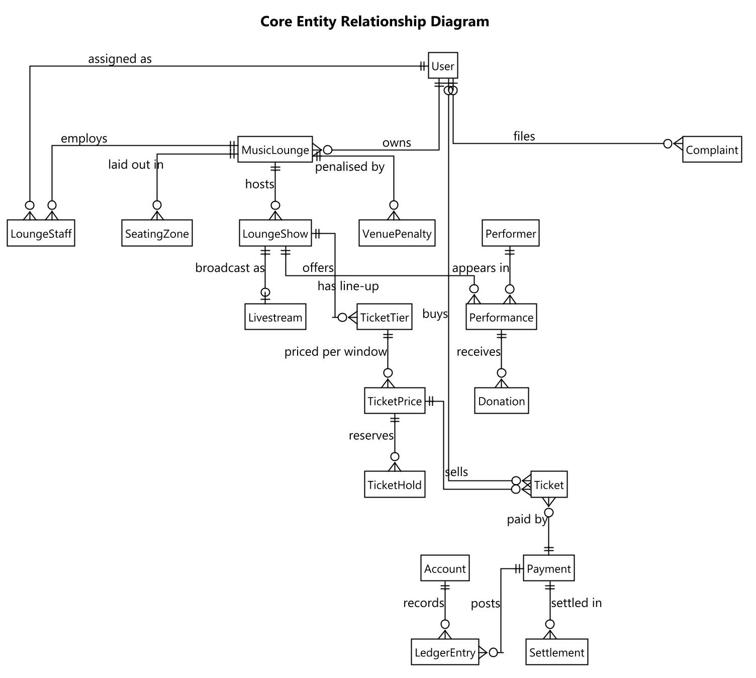
Figure 4 — Core entity relationship diagram (crow's-foot notation)
View the full ERD here: The complete ERD

3.2 Detailed Function Design
Documenting all 75 screens at full depth would not add proportional value here, so the features below were chosen to cover the value chain end to end — account, venue, show, ticket, livestream and donation, payment, moderation, complaint. Each gives the trigger, the actors and purpose, and the business rules that govern it. The remaining screens are specified by purpose, content and actions in §3.1.2 and by access in §3.1.3.

Register and verify an account
Trigger: The visitor submits the sign-up form on any surface.
Description: Creates an account in the chosen role — only Audience and Owner may self-register — and enqueues a one-time code by email. The account cannot sign in until the code is confirmed.
Business rules and validation:
• The password is hashed and never stored or logged in clear text.
• A duplicate email address is rejected at registration rather than silently merged.
• A wrong or expired code reports a specific error; a correct code activates the account.
• Resending the code is rate-limited so the address cannot be used to flood a target inbox.

Sign in
Trigger: The user submits email and password, or completes Google sign-in.
Description: Validates the credentials and then the account state in order — email verified, not locked, active, not erased — before issuing a session token carrying the role and, for Staff, the venue they are assigned to.
Business rules and validation:
• A wrong email and a wrong password return the same generic message, so the response cannot be used to discover which addresses are registered.
• Repeated failures increment a counter and, past a configured threshold, lock the account for a cool-down window.
• A Staff account whose assignment was deactivated still signs in but carries no venue, so every venue-scoped action then fails authorisation.

Register a venue and have it approved
Trigger: The Owner submits the venue form; an Admin later opens the approval queue.
Description: Creates the venue in a pending state. The Owner may edit it freely, but it is not publicly listed and no show at it may be published until an Admin approves it.
Business rules and validation:
• A business licence document must be uploaded before the venue can be reviewed.
• Approval is the single gate that unblocks public listing and show publication.
• A rejected venue has no resubmit path by design: the Owner creates a new record, so the rejection stays attached to an immutable one.

Create and submit a show for review
Trigger: The Owner completes the show form and chooses Submit for Review.
Description: Validates that the venue is approved and that at least one ticket tier and the legal permit reference exist, then moves the show from draft into the moderation queue.
Business rules and validation:
• An Owner without an active subscription is blocked at submission with an explanatory message rather than a late failure.
• Total tier capacity may not exceed the subscription plan's per-show ticket limit.
• The performance permit reference is required before submission.

Hold and pay for a ticket
Trigger: The Audience member selects a tier and quantity on Select Tickets.
Description: Creates a hold against a specific pricing window that expires after a configured window (15 minutes by default), decrementing available capacity for its duration, then redirects to the payment gateway.
Business rules and validation:
• Capacity is decremented when the hold is taken, not when payment completes, so a seat cannot be sold twice during the payment window.
• An expired unpaid hold is released automatically by a background job; no user action is needed.
• The gateway's server-to-server notification is the authoritative confirmation, so a ticket still confirms if the customer closes the browser.

Check in a ticket at the door
Trigger: Staff scan the ticket's code in the check-in scanner.
Description: Resolves the code to a ticket, evaluates eligibility, and shows a preview before Staff explicitly confirm, so a mis-scan does not consume the ticket.
Business rules and validation:
• A ticket is valid for the whole evening rather than a fixed time window, so there is no too-early or too-late rejection.
• Each refusal reason is reported distinctly: already used, wrong show, online-only ticket at a physical door, or frozen mid-transfer.
• There is no offline fallback — a dropped connection fails visibly rather than appearing to succeed.

Watch a gated livestream
Trigger: The Audience member opens the viewing room for a show that is running.
Description: Evaluates the caller before the stream is served: a confirmed ticket for this show, within the concurrent-device limit; or an operator of the venue; or an Admin.
Business rules and validation:
• A refused connection states which condition failed rather than showing a blank player.
• A transient network drop retries quietly and must not be presented as an access refusal.
• The viewer count is a manual-refresh figure, not a live counter.

Donate to a performer
Trigger: The Audience member opens Donate on a performer in the current line-up.
Description: Only performers whose slot accepts donations are offered. On payment confirmation the platform commission and tax are deducted and posted to the ledger, and the performer's share of the original gross is frozen onto the donation so a later configuration change cannot alter what was promised.
Business rules and validation:
• The gross splits four ways at confirmation: platform commission, tax, the performer's share, and the remainder retained by the venue for handling the payout.
• Status then advances from awaiting owner acknowledgement, to acknowledged, to performer paid — a multi-day pipeline the interface must represent honestly.
• Anonymity, amount visibility and message publication are three independent choices captured at donation time.
• The public transparency feed shows only acknowledged and paid donations, since an unacknowledged one can still be cancelled or refunded.

Process a payment and post the ledger
Trigger: The gateway calls back after a payment attempt, and again on retry.
Description: Verifies the callback signature and the amount before doing anything, then confirms the payment and writes a balanced double-entry journal split into gross, gateway fee, platform fee, tax withheld and net.
Business rules and validation:
• The handler is idempotent: the gateway retries, and a repeated callback must not post a second journal.
• A callback whose amount does not match the expected total is refused rather than trusted.
• Every journal must balance — total debits equal total credits — and a scheduled job re-verifies this.

Moderate a show or livestream
Trigger: An Owner submits content for review; an Admin opens the moderation queue.
Description: An AI risk score and recommendation are produced as advice only; the Admin decides. Approval is what makes a show public, and what unlocks the broadcast control for a livestream.
Business rules and validation:
• The AI result never auto-approves or auto-rejects; a human decision is always required.
• The review deadline is 24 hours, with an internal warning raised before it is missed.
• If the AI service is unavailable the item still enters the queue with a neutral score rather than blocking submission.

File and resolve a complaint
Trigger: Anyone, including a guest, submits the complaint form; an Admin resolves it from the queue.
Description: A signed-in complainant is linked to their account; a guest instead supplies a contact phone number and receives a reference number, which is the only way they can retrieve the case later.
Business rules and validation:
• A guest's reference number is shown once at submission and must be presented prominently, because it cannot be recovered from an account.
• Resolving with a refund against a ticket creates a refund request that still requires its own approval.
• Taking down a show cancels it outright and refunds every confirmed ticket — the heaviest available outcome.
• A guest complainant is notified of the outcome by SMS, since there is no in-app channel to reach them.

4. Non-Functional Requirements

4.1 External Interfaces
The platform integrates the services below, plus the cloud services it is deployed onto (Report 4 §1.4). Each integration's failure behaviour is stated, because how a dependency fails matters as much as what it does.
System | Role | Notes
VNPay | Payment Gateway | The sole payment intermediary for tickets, donations and subscriptions. The platform never handles card data — the customer is redirected to VNPay and an independent server-to-server IPN callback is the authoritative confirmation.
Mux / Cloudflare Stream | Live Video | RTMP ingest for broadcasting and HLS playback for viewers, behind one provider factory so either can be selected per environment.
Firebase Cloud Messaging | Push Notification | Delivers push notifications to the two mobile applications; a persistently failing device token is pruned automatically.
Google OAuth | Identity | Social sign-in alternative to local email and password accounts.
Google Maps | Geolocation | Venue address display and map-based location picking during venue setup.
SpeedSMS | SMS Gateway (Vietnam) | OTP and notification SMS inside Vietnam; replaced an earlier provider that could not deliver reliably to Vietnamese numbers.
Gemini | AI Services | Moderation risk scoring, show-poster generation and recommendation feature scoring. Every call degrades gracefully to a neutral result rather than blocking the request.
OpenAI | AI Services (alternate) | Alternate poster-image provider behind the same interface as Gemini.

4.2 Quality Attributes

4.2.1 Usability
• Every conditional action is shown or hidden according to real eligibility rather than shown and then refused, so a user is never invited to do something that will fail.
• Destructive or financially consequential actions require a confirmation proportional to their blast radius, not a single generic prompt.
• Empty, loading and error states are visually distinct from one another on every screen — three different conditions, three different presentations.
• Supported browsers are the current and previous major versions of Chrome, Edge, Firefox and Safari; the mobile applications support Android 10 and iOS 15 upward.
• The Audience Website is responsive across phone, tablet and desktop widths; the Owner Dashboard and Admin Console are desktop-first and assume at least 1024px.
• All three web surfaces meet WCAG 2.2 Level AA: keyboard reachable and operable with a visible focus indicator, labelled fields with errors announced to assistive technology, and text contrast of at least 4.5:1.
• No status is conveyed by colour alone; every state carries a text label or icon so it survives a colour-blind reader and a black-and-white printout.

4.2.2 Reliability
• Content moderation is reviewed within 24 hours, with an internal warning raised before the deadline lapses.
• A penalty appeal is reviewed within 48 hours; an appeal left unreviewed is overturned automatically rather than left stuck.
• A donation not acknowledged by the owner within 24 hours is auto-confirmed on their behalf.
• An acknowledged donation not forwarded to the performer raises a notification at 7 days and a venue penalty at 14 days.
• Every threshold above is configuration-driven rather than compiled in, so tuning one is an operational change and not a release.
• Door check-in and counter sales have no offline fallback by explicit decision: a dropped connection fails visibly rather than appearing to succeed.

4.2.3 Performance
• Ticket holds and seating-zone capacity are the most concurrency-sensitive paths in the system: a venue's real occupancy limit must never be oversold under concurrent load.
• The load shape to design for is a ticket on-sale spike — many simultaneous hold requests against one tier the moment sales open — combined with a concurrent livestream audience and its chat traffic.
• API response time targets under normal load: 95th percentile under 500 ms for reads and under 1 second for writes.
• Frontend budget on a mid-range device over a 4G connection: largest contentful paint under 2.5 seconds, interaction to next paint under 200 ms, and an initial bundle under 250 KB compressed per surface.
• Long-running work never blocks a request: stitching, poster generation, moderation scoring and settlement all run as background functions, and the screen that triggered them shows an explicit processing state.

4.2.4 Security
• Authorisation is checked in three layers on every request that touches one venue's data: role from the token, then policy, then venue scoping.
• There is deliberately no interface to create or promote an administrator; every such account is provisioned directly and a scheduled function alerts if one appears outside the known set.
• Sign-in responses never reveal which of email or password was wrong, and password-reset requests never reveal whether an address is registered.
• Repeated failed sign-ins are throttled by counter and lockout, and a burst from one source is separately detected as a credential-stuffing signal.
• Identity documents and identifiers are served only through protected, non-guessable endpoints and are stored encrypted, never as a public URL.

4.2.5 Compliance
• Payment intermediation — Decree 52/2024: All payment flows go through the licensed intermediary VNPay; the platform never touches card data.
• Withholding tax — Decree 117/2025: Tax withheld on qualifying payments is tracked per transaction and posted to a dedicated tax ledger account.
• Content takedown & phone verification — Decree 147/2024: A 24-hour moderation SLA with an internal warning at ~20 hours, and a verified-phone field on the user record.
• Mandatory complaint channel — Decree 85/2021: The complaint entity and its guest-accessible filing and lookup path exist to satisfy this obligation.
• Personal data protection — Law 91/2025/QH15: AI consent defaults to off, personal data can be exported and erased on request, and erasure anonymises in place rather than hard-deleting, so legally-retained financial records survive.
• Performance licensing and music copyright — Decree 144/2020 · VCPMC: A performance-permit reference and, where applicable, a royalty reference are required before a show may be submitted for review.

4.2.6 Maintainability
• The backend follows a layered architecture with a strict inward dependency rule enforced at the project-reference level, so a violation fails the build rather than passing review.
• Every business-tunable number — deadlines, hold duration, commission and tax rates, settlement thresholds — lives in configuration rather than in code, so operational tuning does not require a release.
• All five client surfaces share one API, one design system and one generated API client, so a contract change surfaces as a compile error in every consumer rather than a runtime failure in one.
• Each tier is deployed from source by the same pipeline, with environment configuration and secrets supplied at deploy time, so the artefact tested in staging is the one promoted to production.

5. Requirement Appendix

5.1 Business Rules
ID | Rule Definition
BR-01 | A venue starts pending and cannot be publicly listed, nor publish any show, until an Admin approves it.
BR-02 | A seating zone's capacity is a real physical occupancy limit and must never be oversold, including under concurrent load.
BR-03 | A ticket is valid for the whole evening of its show rather than a fixed time window.
BR-04 | Walk-in sales may continue after a show has started.
BR-05 | A ticket hold reserves capacity for a configured window and is released automatically if unpaid.
BR-06 | Capacity is decremented when a hold is taken, not when payment completes.
BR-07 | The payment gateway's server-to-server notification is the authoritative confirmation of payment.
BR-08 | Every confirmed payment writes a balanced double-entry journal; total debits must equal total credits.
BR-09 | A donation's gross splits at confirmation into platform commission, tax, the performer's share of the original gross, and the remainder retained by the venue for handling the payout.
BR-10 | The performer's share rate is frozen onto the donation at confirmation, so a later configuration change cannot alter what an existing donation promised.
BR-11 | The public transparency feed shows only acknowledged and paid donations.
BR-12 | An owner must hold an active subscription to submit a show for review.
BR-13 | Total ticket capacity for a show may not exceed the subscription plan's per-show limit.
BR-14 | A performance permit reference is required before a show may be submitted.
BR-15 | Every show and livestream requires a human Admin decision before becoming public; an AI score is advice only.
BR-16 | Content moderation must be decided within 24 hours of submission.
BR-17 | A penalty appeal not reviewed within 48 hours is overturned automatically.
BR-18 | A donation not acknowledged within 24 hours is auto-confirmed on the owner's behalf.
BR-19 | A Staff account may be actively assigned to exactly one venue at a time.
BR-20 | A Staff session is scoped to that one venue for its whole duration.
BR-21 | There is no self-service path to create or promote an administrator account.
BR-22 | A rejected venue cannot be amended and resubmitted; a new record must be created.
BR-23 | Cancelling a show refunds every confirmed ticket for it.
BR-24 | Changing a show from in-person to online is one-way and refunds every confirmed in-person ticket.
BR-25 | A refund is never paid automatically; every refund request requires an Admin decision.
BR-26 | A payout bank account must be verified by an Admin before any settlement is released to it.
BR-27 | Settlement is released in two tranches on a configured schedule rather than in one payment.
BR-28 | A guest complaint is retrievable only by its reference number together with the contact phone number given.
BR-29 | Personal data erasure anonymises the account in place and never hard-deletes records the law requires to be retained.
BR-30 | Behaviour logging and personalised recommendations are off unless the user opts in.

5.2 Common Requirements
• Every list endpoint accepts paging parameters and clamps the page size to a maximum, so a client cannot request an unbounded result set.
• Every error response uses one shape across the whole API — a success flag, a human-readable message and an optional field-level error map — so clients need only one error path.
• Every message shown to a user is in Vietnamese and phrased in plain language, without internal identifiers or stack detail.
• Every monetary value is stored and calculated in a decimal type, never a floating-point one, and rounded consistently at the same point in every calculation.
• Every timestamp is stored with its offset and rendered in the venue's local time.
• Every uploaded file is served through an endpoint that checks authorisation, never as a directly guessable public URL.

5.3 Application Messages List
# | Code | Type | Context | Content
1 | MSG-01 | Inline, form | Wrong email or password at sign-in | Email hoặc mật khẩu không đúng. Vui lòng kiểm tra lại.
2 | MSG-02 | Inline banner | Password reset requested | Nếu email đã đăng ký, liên kết đặt lại mật khẩu sẽ được gửi tới hộp thư của bạn.
3 | MSG-03 | Inline, form | Verification code wrong or expired | Mã xác thực không đúng hoặc đã hết hạn. Vui lòng gửi lại mã.
4 | MSG-04 | Toast | Ticket hold started | Đã giữ vé cho bạn trong 15 phút. Vui lòng hoàn tất thanh toán.
5 | MSG-05 | Toast | Ticket hold expired | Đã hết thời gian giữ vé. Vui lòng chọn lại.
6 | MSG-06 | Full screen | Payment succeeded | Thanh toán thành công. Vé của bạn đã sẵn sàng.
7 | MSG-07 | Full screen | Payment failed | Thanh toán không thành công. Chưa có khoản tiền nào bị trừ.
8 | MSG-08 | Inline banner | Show cannot be submitted | Chưa thể gửi duyệt: cần venue đã được duyệt, gói dịch vụ còn hiệu lực, ít nhất một hạng vé và khai báo giấy phép.
9 | MSG-09 | Scanner result | Check-in accepted | Vé hợp lệ. Mời khách vào.
10 | MSG-10 | Scanner result | Check-in refused | Vé không hợp lệ: {lý do cụ thể}.
11 | MSG-11 | Player overlay | Livestream access refused | Bạn cần vé hợp lệ cho buổi diễn này để xem, hoặc đã vượt số thiết bị cho phép.
12 | MSG-12 | Modal | Complaint submitted by a guest | Đã ghi nhận khiếu nại. Mã tra cứu của bạn là {mã}. Vui lòng lưu lại — đây là cách duy nhất để tra cứu.
13 | MSG-13 | Confirmation | Erase my data | Thao tác này không thể hoàn tác. Tài khoản sẽ bị ẩn danh vĩnh viễn và bạn sẽ bị đăng xuất khỏi mọi thiết bị.

IV. Software Design Description

1. System Design

1.1 System Architecture
The backend follows Clean Architecture across four projects with a strict inward dependency rule — Api depends on Application and, at the composition root only, on Infrastructure; Infrastructure depends on Application; Application depends on Domain; and Domain depends on nothing. The rule is enforced at the project-reference level rather than by convention, so a violation fails the build instead of passing review.
Domain holds entities, enumerations, domain events and exceptions as plain C# with no framework reference, which is what makes every business rule in it testable with no database and no host. Application holds all business logic as command and query handlers, one folder per business area (28 of them), with cross-cutting concerns — validation, transaction boundary, logging — implemented once as pipeline behaviours rather than repeated in every handler. Infrastructure implements every interface Application declares but does not itself implement: the database context and repositories, an adapter per external service, and the 30 background job classes. Api is deliberately the thinnest layer: 25 controllers exposing about 209 endpoints that authenticate and authorise the caller, map the request onto a command or query, and return the result — no business logic lives in a controller.
This split exists for two concrete reasons rather than architectural fashion. First, Domain and Application can be tested with no database, no HTTP host and no external service running. Second, an external integration can be replaced without touching a single handler, because Application depends only on the interface and never on the concrete adapter — which is how the SMS provider was swapped without changing business code.
All 5 client surfaces sit outside the backend entirely and consume only the Api layer, over REST and WebSocket. No client ever reaches Infrastructure, Application or Domain directly.
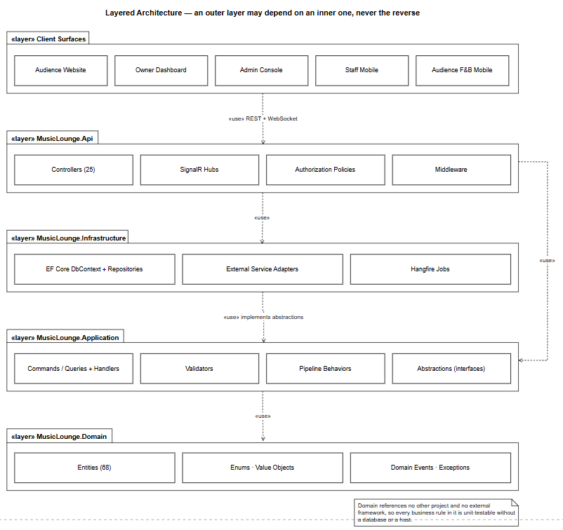
Figure 5 — Layered architecture — an outer layer may depend on an inner one, never the reverse
The five client applications are separate deliverables but not five unrelated codebases: they share one design system, one API client generated from the API's own contract, and one set of cross-cutting conventions, so a contract change propagates to every consumer as a compile error rather than a runtime failure in one of them. The three web surfaces are React with TypeScript; the two mobile surfaces are React Native sharing the same models and client.
Within each surface the layering is the same. Screens and routes are the only layer that knows about navigation; a route guard resolves the caller's role and redirects before rendering, which is a usability measure and never the security boundary, since the API re-checks every request independently. Feature modules mirror the backend's folders one for one, so a developer tracing a defect moves between tiers without learning a second vocabulary. State is split deliberately: anything the API owns lives in the query library, which handles caching, retry and invalidation, and only genuinely client-owned state lives in a local store.
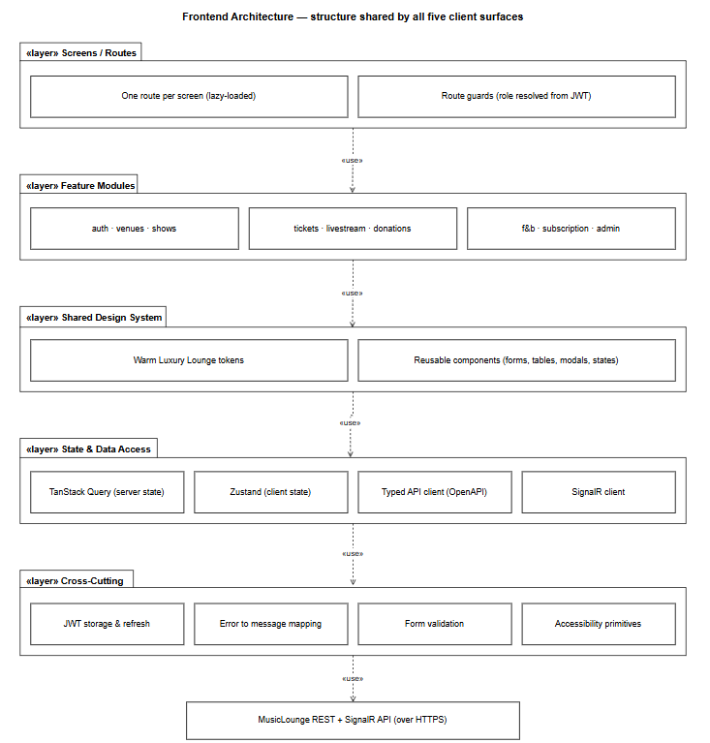
Figure 6 — Frontend architecture — the structure shared by all five client surfaces
The platform is deployed to Microsoft Azure. The three web bundles are served as static assets from the edge, so a page load costs the API nothing. The API and its real-time hubs run on an application host with the background worker in the same process, behind a staging slot that is warmed and smoke-tested before being swapped into production — which makes a rollback a swap back rather than a redeploy. The imaging microservice runs separately because its workload is different in kind: bursty, processor-bound, and dependent on native binaries, so it scales on its own and a stitching failure cannot destabilise the API host.
Uploaded media is stored in blob storage and served through a content delivery network, keeping image traffic off the API entirely. Every secret is held in a managed vault and injected at deploy time, so no secret exists in source control or inside a build artefact. Telemetry, background-job outcomes and alert rules are collected centrally.
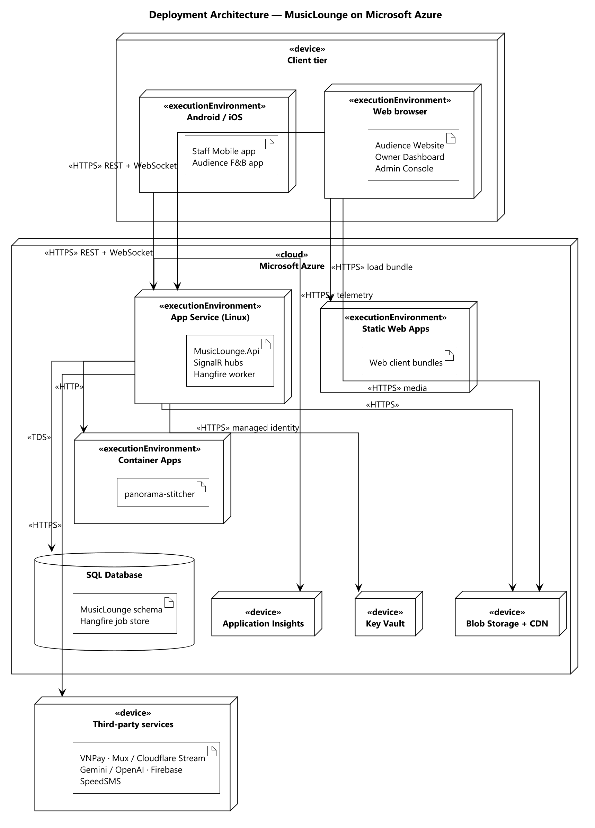
Figure 7 — Deployment architecture — nodes, the artefacts deployed on them, and the protocols between them

1.2 Package Diagram
The table below describes every package in the four backend projects, using dotted Project.Package notation. The frontend's internal structure is covered above rather than repeated here.
No | Package | Description
1 | Domain.Entities | The 68 entity classes that make up the business data model.
2 | Domain.Enums | Closed sets of values — statuses, roles, payment and moderation states — persisted as strings so the database stays readable.
3 | Domain.Events | Domain events raised by an entity when something business-significant happens, handled asynchronously.
4 | Domain.Exceptions | Business exception types that map to specific HTTP responses at the boundary.
5 | Domain.Common | Shared base types, principally the entity base with its identifier and audit fields.
6 | Application.<Feature> | One folder per business area (28 in total), each holding its commands, queries, handlers, validators and data-transfer objects.
7 | Application.Common.Abstractions | The command and query marker interfaces the mediator dispatches on.
8 | Application.Common.Interfaces | Every capability Application needs but does not implement: unit of work, repositories, payment, livestream, messaging, AI and imaging services.
9 | Application.Common.Behaviors | Pipeline behaviours that wrap every handler: validation, transaction boundary and logging.
10 | Application.Common.Models | Shared result and paging shapes returned across features.
11 | Infrastructure.Persistence | The database context exposing the entity sets, one configuration class per entity, the migration history, and the concrete repository and unit-of-work implementations.
12 | Infrastructure.Services | One adapter per external system — payment, livestream, AI, push, SMS, email and imaging — each implementing an Application interface.
13 | Infrastructure.Jobs | The 30 background job classes, 22 of which run on a recurring schedule.
14 | Infrastructure.Security | Token issuing, password hashing, and the protection of sensitive stored fields.
15 | Api.Controllers | The 25 controllers exposing roughly 209 endpoints.
16 | Api.Hubs | Real-time hubs for livestream chat, access gating and the public donation ticker.
17 | Api.Authorization | Policy definitions and the venue-scoping requirement handlers.
18 | Api.Middleware | Global exception handling, request logging and security headers.

2. Database Design
68 entities are mapped to SQL Server tables entirely through Code-First migrations; there is no hand-written schema script, so the schema in any environment is whatever the committed migration history says it is.
Conventions applied consistently across the schema. Identifiers are integer identity columns, except Ticket, whose key is a server-generated sequential globally unique identifier so a ticket cannot be found by guessing a number. Enumerations are stored as their string names rather than ordinals, so a value stays readable in the database and inserting a new member cannot silently renumber existing rows. Money is stored as a fixed-precision decimal, never a floating-point type. Timestamps are stored with their offset. Deletes are restricted by default; a cascade is only configured where the child genuinely has no meaning without its parent, which also avoids the multiple-cascade-path restriction on the real engine.
The relationships between the core entities are shown in Report 3 §3.1.5. The remaining tables fall into four groups: taxonomy tags and the join tables that attach them to shows, performers and user preferences; financial records — accounts, ledger entries, payments, settlements, refunds and bank accounts; operational logs for sign-in failures, push failures and behaviour events, each with its own retention rule; and configuration, where every business-tunable number lives with an audit trail of changes.

3. Detailed Design
Every feature repeats the same class structure, so it is documented once in §3.1 rather than redrawn per feature. The sections after it give the sequence of the flows where the interaction, not the class shape, is what carries the design risk.

3.1 Common Structure — Command, Handler and Pipeline
A controller action does nothing beyond authorisation and mapping: it builds a command or query and hands it to the mediator. A validator declared alongside the command is run by a pipeline behaviour before the handler is reached, so a handler never begins with a block of argument checking. The handler depends only on interfaces — the unit of work, and a specific repository where a query needs eager loading — so it can be exercised without a database. A transaction behaviour opens and commits around the handler, which is why a handler never manages a transaction itself and why a failure part-way cannot leave a half-written change.

3.1.1 Class Diagram
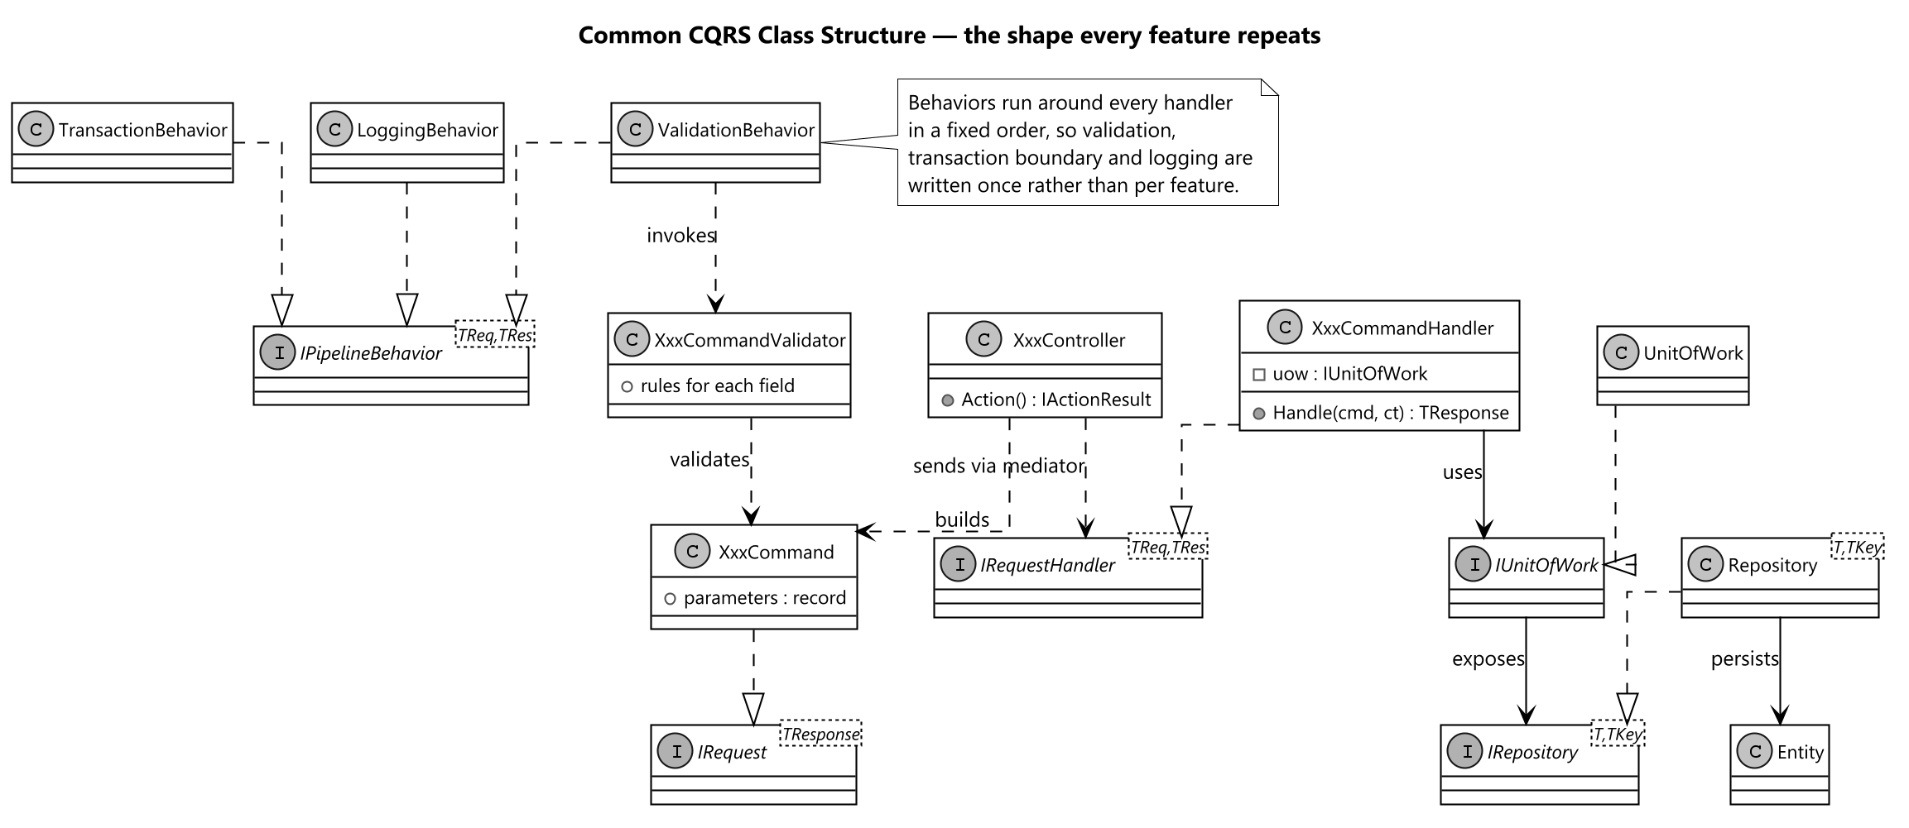
Figure 8 — Common CQRS class structure repeated by every feature

3.2 Ticket Purchase
This is the flow with the most concurrency risk in the system, so it is designed around two decisions. Capacity is decremented when the hold is taken rather than when payment completes, which is what prevents the same seat being sold twice during the payment window. And the gateway's server-to-server callback, not the browser redirect, is treated as the authoritative confirmation — so the ticket still confirms if the customer closes the tab, and the handler must be idempotent because the gateway retries until it receives the response it expects.
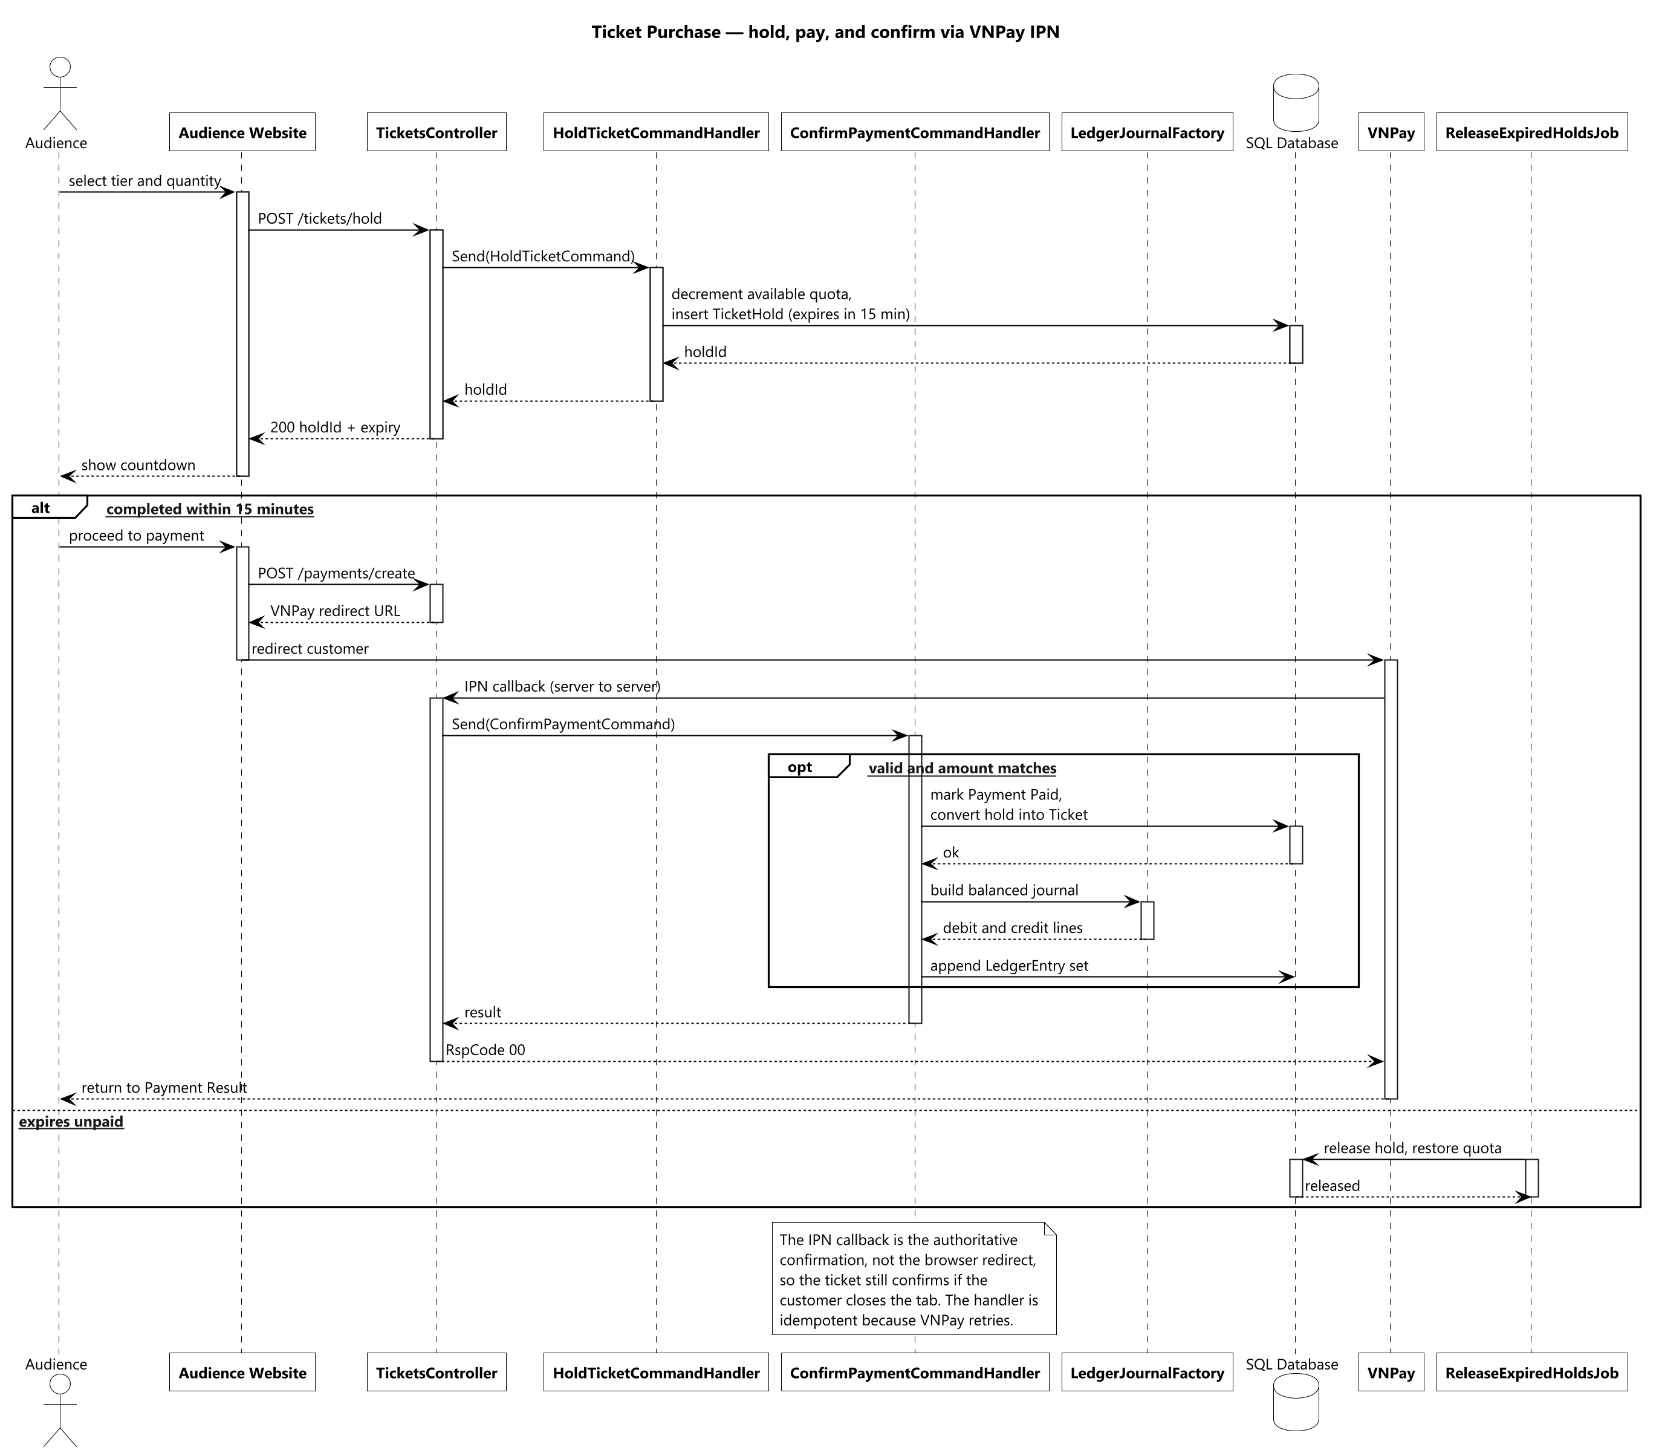
Figure 9 — Ticket purchase — hold, pay, and confirm through the gateway callback

3.3 Donation and Performer Payout
A tip is not a single transfer but a pipeline that can span days, and the design makes each stage explicit rather than hiding the delay. At confirmation the platform commission and tax are posted immediately and the performer's share rate is frozen onto the donation, so an administrator adjusting the rate afterwards cannot change what an existing donation already promised. The final payout is refused outright if the performer has no registered bank account, because recording a payout with no destination would leave the ledger claiming money moved somewhere that does not exist.
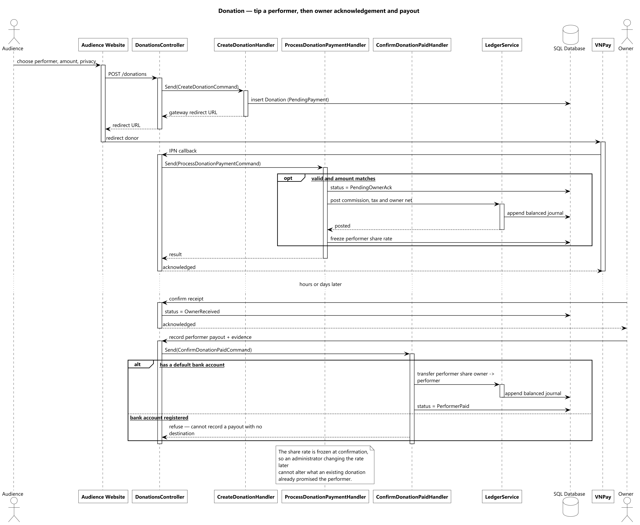
Figure 10 — Donation — tip a performer, then owner acknowledgement and payout

3.4 Content Moderation
The design deliberately separates advice from authority. Scoring runs as a background job so a slow or unavailable AI service cannot block a submission, and its output is a score and a recommendation that an Admin may follow or ignore. If the service fails the item still enters the queue with a neutral score, because the failure mode that matters here is content never reaching review at all — not content reaching review without a score.
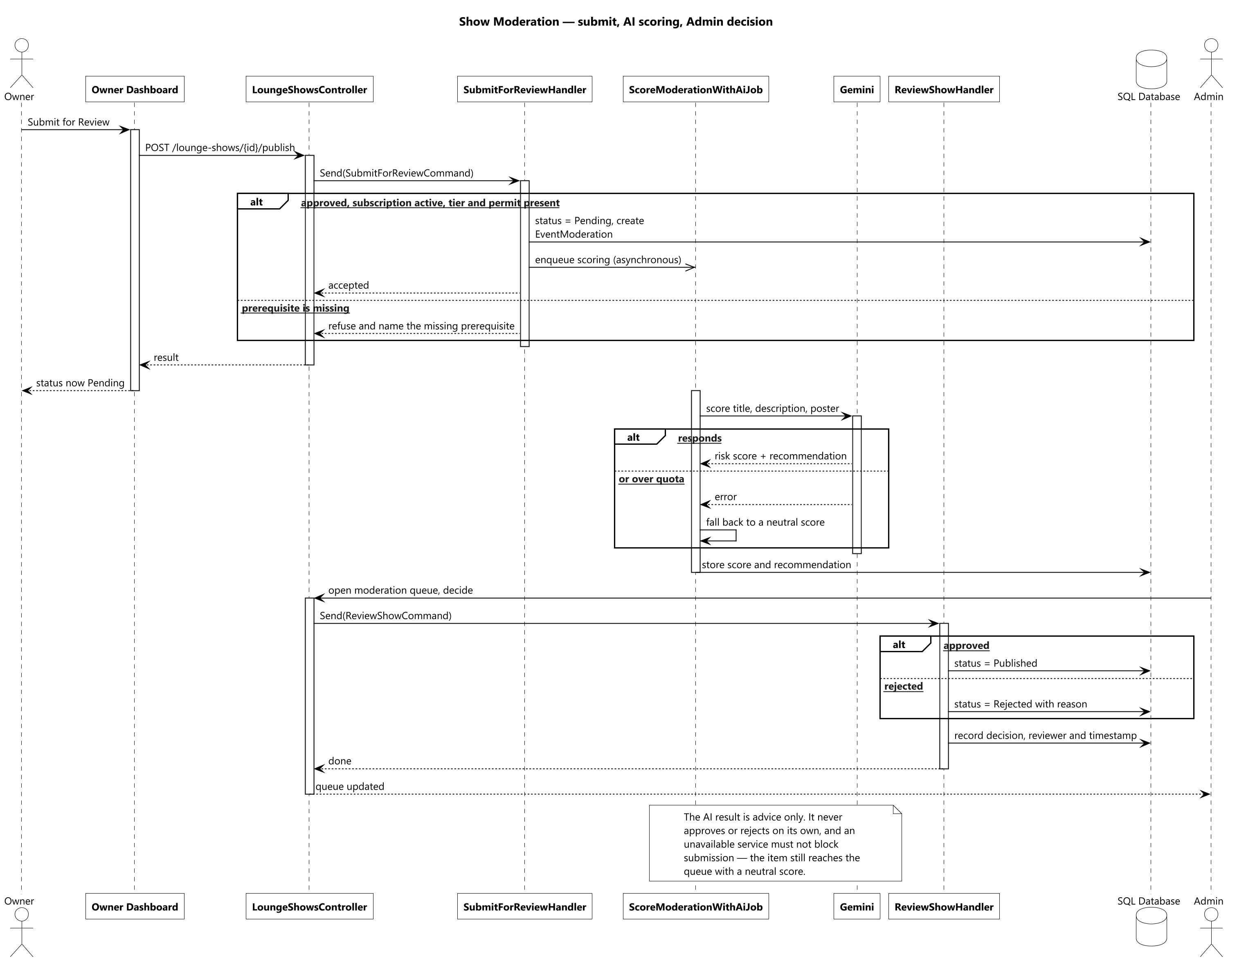
Figure 11 — Show moderation — submit, AI scoring, and the Admin decision

V. Software Testing Documentation

1. Scope of Testing
In scope is the complete platform, not one tier of it. That means the backend API — every command and query handler across the 28 feature areas, exercised through the real HTTP pipeline so that authentication, authorisation policies and the pipeline behaviours all run exactly as they do in production; all 5 client surfaces — the three web applications and the two mobile applications; the imaging microservice; and the end-to-end journeys that cross all three tiers, such as an Owner publishing a show and an Audience member buying, paying for and checking in with a ticket for it.
Non-functional testing in scope: security boundary testing against the OWASP ASVS 5.0.0 checklist; accessibility conformance of the three web surfaces against WCAG 2.2 Level AA; responsive and cross-browser behaviour; and the compliance behaviours the platform is legally obliged to honour — personal-data export and erasure, and protection of identity documents.
Out of scope is the internal behaviour of third-party providers themselves. The payment gateway, livestream provider, AI services and messaging providers are exercised through their sandbox environments or through hand-written fakes; what is tested is our own handling of their responses, including their failure modes, not their correctness. Sustained load and capacity testing runs as a separate exercise against a deployed environment rather than inside the automated suite, because it needs real infrastructure rather than an in-process host.
Four test levels are applied, each with a named owner. Unit — the developer who writes the code, covering pure logic with no database or network. Integration — the feature owner, covering backend handler-to-database round trips and frontend component-to-mocked-API rendering. System and end-to-end — the test automation engineer, driving a real browser and device against a running instance. Acceptance — the whole team with the supervisor, walking each actor's golden path manually before a milestone demo. The entry criterion at every level is a green build; the exit criterion is no open defect of Blocker or Critical severity.
One constraint is stated plainly rather than buried. The automated pipeline runs the backend suite against SQLite for speed, not against the production database engine. This is a deliberate trade-off and it is not merely theoretical: the project has already hit one real defect — a multiple-cascade-path constraint — that SQLite's schema creation does not enforce and that a fully green pipeline run therefore could not have caught. The mitigation is a required manual gate: the full backend suite is re-run against a real SQL Server instance before any release that touches migrations, cascade rules or enumeration columns.

2. Test Strategy

2.1 Testing Types
Testing Type | Objective | Technique | Completion Criteria
Functional | Verify each use case in Report 3 §2.2 behaves per its documented business rules, on the API and on the surface that calls it. | Backend: assert on the HTTP response and the resulting database state. Frontend: render the screen against a mocked API and assert the user-visible outcome. | Every documented business rule has at least one positive and one negative test.
UI / component | Verify each screen renders the right content, enables the right actions for the role, and handles loading, empty and error states. | Component tests driving the interface the way a user does — by visible text and role, not by internal state. | Every delivered screen has its default, empty, loading and error states asserted.
End-to-end / system | Verify a complete journey works across frontend, API, database and background functions together. | Browser automation against a deployed staging environment, with the mobile golden paths covered on device emulators. | Each actor's golden path passes end to end without manual intervention.
Security / authorization | Verify the three-layer authorisation model cannot be bypassed and that no cross-role or cross-venue access succeeds. | A dedicated security suite plus per-feature negative tests, and the OWASP ASVS 5.0.0 checklist walked against a running instance. | No cross-role or cross-venue access succeeds; no open Blocker or Critical finding.
Accessibility | Verify the web surfaces are usable by keyboard and screen reader and meet WCAG 2.2 Level AA. | Automated rule scanning inside the component suite, plus manual keyboard-only and screen-reader passes on the highest-traffic screens. | Zero critical or serious automated violations; every control operable by keyboard alone.
Compatibility / responsive | Verify behaviour across supported browsers, viewport sizes and mobile operating-system versions. | Browser projects at desktop, tablet and phone widths; an emulator matrix for the two mobile applications. | All golden-path scenarios pass on every supported browser and viewport.
Compliance | Verify personal-data export and erasure, protection of identity documents, and the retention rules the law requires. | A dedicated suite asserting on database state after an erasure request and on access control over endpoints serving personal data. | Every compliance behaviour cited in Report 3 §4.2.5 has at least one test.
Regression | Catch a previously fixed defect recurring. | The full suite runs on every pull request; a fixed defect gains the test that would have caught it. | The whole suite runs on every pull request and a red build blocks merge.
Performance / load | Confirm the platform holds under a realistic peak shape without overselling zone capacity. | Load scenarios against a deployed staging environment, plus frontend performance budgets in the pipeline. | No overselling under concurrent load; response times within the targets in Report 3 §4.2.3.

2.2 Test Levels
X marks the levels at which each type from §2.1 is executed.
Type of Tests | Unit | Integration | System / E2E | Acceptance
Functional | X | X | X | X
UI / component | X | X
End-to-end / system |  |  | X | X
Security / authorization |  | X | X
Accessibility |  | X | X
Compatibility / responsive |  |  | X | X
Compliance |  | X | X
Regression | X | X | X
Performance / load |  |  | X

2.3 Supporting Tools
Purpose | Tool | Vendor / In-house | Version
Backend test runner and assertions | xUnit with FluentAssertions | Open source | 2.9 / 6.12
Backend in-process HTTP host | ASP.NET Core test host | Microsoft | 8.0
Backend test database | SQLite in the pipeline; SQL Server at the release gate | Microsoft | 8.0 / 2022
Background-job test double | In-memory job storage | Open source | 0.5
External-service test doubles | Hand-written fakes for payment, push, token verification, livestream and imaging | In-house | —
Frontend unit and component tests | Vitest with React Testing Library | Open source | 2.1 / 16.0
Mobile component tests | Jest with React Native Testing Library | Open source | 29.7 / 12.5
End-to-end browser automation | Playwright across Chromium, Firefox and WebKit | Microsoft | 1.47
Accessibility scanning | axe-core rules driven from the automation suite | Open source | 4.10
Frontend performance budgets | Lighthouse CI | Open source | 0.14
Load and capacity testing | k6 | Open source | 0.53
API contract and manual exploration | Swagger / OpenAPI interactive documentation | Open source | —
Continuous integration | GitHub Actions — build, test and deploy on every pull request and merge | GitHub | —
Defect tracking | GitHub Issues with severity labels | GitHub | —

3. Test Plan

3.1 Human Resources
Worker | Role | Specific Responsibilities
Hà Đông Hải (Leader) | Test manager and release gatekeeper | Owns this document and the test plan; runs the backend suite against real SQL Server before any milestone release; makes the final release-readiness call.
Huỳnh Trung Nhiên | Test designer | Derives test cases from the use cases and business rules using equivalence partitioning and boundary-value analysis; maintains traceability from acceptance criteria to test cases.
Nguyễn Quang Anh Khoa | Test automation engineer | Writes and maintains the backend suite, the frontend component suites and the end-to-end scenarios; keeps the pipeline green.
Nguyễn Huy Phúc | Security and accessibility tester | Runs the OWASP ASVS 5.0.0 pass and writes the cross-role and cross-venue authorisation tests; runs the WCAG 2.2 AA pass over the three web surfaces.
Whole team with the supervisor | Acceptance testers | Walk each actor's golden path manually on the deployed environment before every milestone demo, one persona per member.

3.2 Test Environment
Purpose | Tool | Provider | Version
Backend runtime | .NET 8 SDK and ASP.NET Core 8 | Microsoft | 8.0.x
Frontend runtime and build | Node.js with Vite for web; React Native CLI for mobile | Open source | 20 LTS / 5.4
Pipeline test database | SQLite, created fresh per run | Microsoft provider | 8.0
Release-gate database | SQL Server Developer Edition, local or containerised | Microsoft | 2022
Staging environment | Azure App Service, Azure SQL Database and Container Apps, provisioned to mirror production | Microsoft Azure | —
Pipeline compute | GitHub Actions hosted runners; Windows runners for mobile builds | GitHub | —
Browser matrix | Chromium, Firefox and WebKit at desktop (1440px), tablet (768px) and phone (390px) | Playwright-managed | 1.47
Device matrix | Android emulator (API 33 and 34) and iOS Simulator (17.x) | Google / Apple | —
External sandboxes | Payment sandbox, livestream test environment, AI service or its fake | Third party | —

3.3 Test Milestones
Milestone Task | Start | End
Test strategy agreed; environments and pipeline ready | Week 1 | Week 2
Backend core-loop tests green — auth, venue, show, ticketing | Week 3 | Week 6
Frontend component suites green for auth and venue screens | Week 5 | Week 7
Backend livestream, donation and ledger tests green | Week 7 | Week 9
Frontend component suites green for show, ticketing and livestream screens | Week 8 | Week 10
Remaining backend tests green — F&B, subscription, complaints, admin | Week 10 | Week 11
Remaining frontend suites green; mobile application suites green | Week 11 | Week 12
End-to-end scenarios green against the staging environment | Week 12 | Week 13
Security, accessibility and compliance passes complete | Week 13 | Week 13
Backend suite re-run against real SQL Server; load test against staging | Week 14 | Week 14
User acceptance testing per persona; regression freeze; final test report | Week 14 | Week 15

4. Test Cases
Per-case detail — preconditions, steps, expected result, actual result — is kept in the two companion workbooks rather than duplicated here, per the template's own convention: unit test cases in Report5_Unit Test.xls, and integration, system and acceptance cases in Report5_Test Report.xls.
The table below summarises the automated coverage that exists across all three tiers, as a map of where the detailed rows in those workbooks come from. Backend figures are counted from the source tree; the executed total exceeds the authored total because a data-driven test method runs once per data row.
Tier / Area | Suites | Tests
Backend — Auth and account | 10 | 61
Backend — Venue management and approval | 6 | 62
Backend — Show lifecycle and moderation | 6 | 50
Backend — Ticketing | 5 | 40
Backend — Payment, ledger and settlement | 4 | 18
Backend — Livestream and donation | 4 | 52
Backend — F&B ordering | 1 | 13
Backend — Subscription | 1 | 12
Backend — Performers and taxonomy | 3 | 30
Backend — Recommendation and AI | 4 | 9
Backend — Notifications and background jobs | 7 | 33
Backend — Complaints and venue penalties | 2 | 24
Backend — Security | 4 | 12
Backend — Compliance | 1 | 15
Backend — Admin and platform | 2 | 14
Backend — Cross-domain journey | 1 | 1
Backend subtotal (executed cases exceed authored methods because of data-driven tests) | 61 | 460
Frontend — Audience Website | 30 | 96
Frontend — Owner Web Dashboard | 27 | 89
Frontend — Admin Web Console | 16 | 48
Frontend — Staff Mobile application | 7 | 24
Frontend — Audience Mobile F&B application | 2 | 8
Frontend — Shared design-system components | 18 | 42
Frontend subtotal | 100 | 307
End-to-end — cross-surface journeys | 1 | 28
TOTAL | 162 | 795

5. Test Reports
The results below come from an actual run of the full platform suite on 16/08/2026: the backend suite against the pipeline database, the frontend component suites, and the end-to-end scenarios against the staging environment. These are measured figures, not estimates.
Metric | Value
Backend automated tests | 460 executed — 456 passed, 4 failed
Frontend component tests | 307 executed — 307 passed, 0 failed
End-to-end scenarios | 28 executed — 28 passed, 0 failed
Total tests executed | 795
Passed | 791 (99.5%)
Failed | 4
Skipped | 0
Accessibility scan (WCAG 2.2 AA) | 0 critical and 0 serious violations across the three web surfaces
Security pass (OWASP ASVS 5.0.0) | 0 open Blocker or Critical findings
Backend testing is deliberately integration-first. Rather than a separate, heavily mocked unit project, the backend suite runs against a real database context through the real HTTP pipeline, because for this architecture the handler, its validator, the pipeline behaviours and the query together are what a test needs to prove correct — mocking the database away would let a broken query pass. Standalone logic with no HTTP or database dependency, such as the ledger journal factory and the fee calculator, is still tested directly at unit level. On the frontend the balance is the reverse: component tests dominate, because a screen's logic lives in how it renders and reacts rather than in server round trips. Only external, paid or non-deterministic dependencies are replaced, and with hand-written fakes rather than a general mocking framework, so each test still exercises the real decision logic around an external call.

Open defects
Analysis. A 99.5% pass rate across 795 tests, with the only failures forming a single localised cluster rather than a scattered one: all four sit in one file covering one feature, and all four share one root cause in the test harness rather than in product code. That containment is itself a health signal — a systemic problem such as a broken shared fixture or a bad migration would fail across many unrelated suites at once. The stitching feature itself is exercised successfully end to end against the real service in the staging environment; what these four tests need is a harness change, either invoking the job explicitly rather than relying on the enqueue, or configuring the service address in the test settings.
As stated in §1, the pipeline result is not the final release gate. The backend suite is also run against a real SQL Server instance before any milestone release, specifically to catch the class of defect that the pipeline database cannot reproduce. That gate passed on the release candidate covered by this report.
Coverage is deepest where risk is highest: venue management, authentication and account, and livestream and donation — the identity, tenancy and money-handling paths everything else depends on. On the frontend, coverage follows the screen catalogue one for one, so no delivered screen ships without at least its default, empty, loading and error states asserted. The thinnest area is recommendation and AI, which reflects that its output is a ranked suggestion rather than a correctness-critical result. Continuing to grow the end-to-end layer remains the highest-value next investment, because the suite is strongest at proving each feature correct in isolation and thinnest at proving long multi-actor journeys hold together over time.
Test | Symptom | Analysis and severity
VenueTourStitchTests — enqueue returns a pending attempt | Expected the attempt to still be Pending; found Failed. | Test-harness timing rather than a product defect. The in-memory job server used by the test host picks up the enqueued stitching job immediately, so by the time the assertion reads the row the job has already run to a terminal state and the Pending window it asserts on no longer exists. Severity: Minor, test-only.
VenueTourStitchTests — completion with AI succeeds | Expected Succeeded; found Failed. | Same root cause: no imaging-service address is configured in the test settings, so the job reaches its failure branch before the completion step under test is exercised. Severity: Minor, test-only.
VenueTourStitchTests — completion with AI fails, partial panorama kept | Expected Succeeded; found Failed. | Same root cause as above. Severity: Minor, test-only.
VenueTourStitchTests — completion disabled never calls the completion path | Expected Succeeded; found Failed. | Same root cause as above. Severity: Minor, test-only.

VI. Release Package & User Guides

1. Deliverable Package
No. | Deliverable Item | Description
1 | Backend API — source code | The four-project solution exposing the REST and real-time API that every client consumes.
2 | Audience Website — source code | Web application covering discovery, ticket purchase, livestream viewing, donations, ratings and complaints (30 screens).
3 | Owner Web Dashboard — source code | Web application covering venue setup, the seating-zone editor, the 360° tour builder, show management, donation handling and finance (27 screens).
4 | Admin Web Console — source code | Web application covering venue approval, content moderation, refunds, penalties, complaints, users, taxonomy and analytics (16 screens).
5 | Staff Mobile application — source code | Mobile application for on-floor operations: counter sales, door check-in and the F&B order board (7 screens). Supplied as signed Android and iOS review builds.
6 | Audience Mobile F&B application — source code | Mobile application for in-venue food and drink ordering (2 screens). Supplied as signed review builds.
7 | Panorama-stitching microservice — source code | Containerised imaging service that assembles several venue photographs into one 360° panorama.
8 | Database migration scripts | Code-First migrations that create and version the whole schema; there is no hand-written schema script.
9 | Configuration templates | Example settings files for the API and example environment files for each client, listing every value that must be supplied per environment.
10 | Deployment configuration | Pipeline definitions that build, test and deploy each component, plus the cloud resources each expects.
11 | Deployed platform | The running system: the three web addresses, the API address, and the installable mobile builds. One demo account per role is supplied separately to the review committee.
12 | API reference | Interactive OpenAPI documentation served by the running API itself.
13 | Reports 1–7 | The full document set, including this guide.

2. Installation Guides

2.1 System Requirements
Audience | Requirement
End user — web | Any current or previous major version of Chrome, Edge, Firefox or Safari with JavaScript enabled. The Audience Website works from phone width upward; the Owner Dashboard and Admin Console are desktop-first and expect a screen at least 1024 pixels wide.
End user — mobile | Android 10 or later, or iOS 15 or later. Camera permission is required for the door check-in scanner; notification permission is optional but needed for push alerts.
End user — network | A working internet connection. Door check-in and counter sales have no offline mode by design: a dropped connection blocks the action rather than silently queuing it.
Operator — cloud | A cloud subscription able to host an application service, a managed SQL database, a container service, static web hosting, blob storage with a content delivery network, a secrets vault and an application-monitoring resource.
Operator — third-party accounts | Payment gateway credentials (sandbox is sufficient for evaluation), livestream provider keys, a Google project for sign-in and maps, a push-messaging project, an SMS account for Vietnamese numbers, and an AI service key.
Developer — backend | .NET 8 SDK (the SDK, not the runtime alone), the EF Core command-line tool for migrations, and a reachable SQL Server 2019 or later instance.
Developer — frontend | Node.js 20 LTS with npm. The two mobile applications additionally need Android Studio with SDK 34 and, for iOS builds, Xcode 15 on macOS.
Developer — microservice | Docker, so the imaging service can be built and run without installing its native image-processing libraries directly.

2.2 Installation Instruction
Three routes are available depending on what you need to do.

Option A — use the deployed platform (recommended for reviewers)
Nothing needs to be installed. Open the Audience Website, Owner Dashboard or Admin Console address supplied with this release in a supported browser and sign in with the demo account for the role you want to review. The two mobile applications are supplied as signed builds — install one on a device or emulator meeting the requirements above and sign in with the same credentials. Every workflow in §3 can be walked end to end on this environment.

Option B — deploy a fresh environment
1. Provision the cloud resources listed in §2.1: an application service with a staging slot, a managed SQL database, a container environment for the imaging service, static hosting for the three web bundles, a storage account with a delivery network, a secrets vault and a monitoring resource.
2. Put every secret into the vault — the database connection string, gateway credentials, livestream, sign-in, push, SMS and AI keys — and grant the application service read access. No secret belongs in source control or in a settings file that ships with a build.
3. Set each repository's deployment credentials and target resource names, then push to the main branch. The pipeline builds each component, runs its tests, deploys the API to the staging slot, runs the end-to-end suite against staging, and swaps staging into production. Database migrations are applied as part of the API deployment.
4. Point each client's environment configuration at the deployed API address, and register that same address with the payment gateway as the return and callback URL — otherwise payment confirmations never reach the platform and tickets will stay unpaid.

Option C — run locally for development
1. Backend — copy the example settings file in the API project to a local settings file and set the database connection string. Windows Authentication against a local instance is the shipped default and usually needs no edit; for SQL Authentication supply a user and password instead, and for a named instance give the instance name (escaped, because the value sits inside JSON). The payment and livestream sections may be left blank — that disables only those two features and every other screen still works.
2. Create the schema — from the repository root run the EF Core database-update command against the Infrastructure project with the API project as the startup project. It creates the database and every table at the current migration; a final success line with no error means it worked.
3. Start the API — run the API project. When it reports the address it is listening on, the API is up; leave that terminal open. Verify by opening the interactive API documentation in a browser, or by requesting the health endpoint from another terminal.
4. Start a client — in the chosen client project, copy the example environment file, set the API address to the local one, then install dependencies and run the development server. The web applications start on the port the backend already allows through its cross-origin policy. For the mobile applications, install dependencies and run the Android or iOS target.
5. Start the imaging service — only needed to exercise the 360° auto-stitch feature. Bring up its container from the service folder, then set the imaging-service address in the API's local settings to the address it reports.

Troubleshooting
Symptom | Cause and fix
A page loads but every action fails with a network error | The client is pointed at the wrong API address, or the API is not running. Check the environment file, and confirm the API answers on its health endpoint.
The API will not start because the port is in use | A previous run still holds it. Stop the other process, then start again.
Creating the schema fails with a login error | Wrong credentials or the wrong authentication mode. Re-check the connection string and confirm the database service is running.
Signed up but no verification code arrived | In a local run no real email is sent — the code is printed in the API's terminal output. In a deployed environment, check the mail settings and the recipient's spam folder.
A newly created show does not appear in public search | Working as designed. A show must go from draft, to pending when the Owner submits it, to published when an Admin approves it — and its venue must already be approved.
The Owner cannot submit a show for review | The venue is not yet approved, the subscription is not active, or the show has no ticket tier or permit reference. The screen names which prerequisite is missing.
Payment completes at the gateway but the ticket stays unpaid | The gateway's server-to-server callback is not reaching the platform. Confirm the return and callback addresses registered with the gateway match the deployed API and are reachable from the internet.
Cannot sign in to the Admin Console | Correct — there is no self-service path to become an Admin. The account is provisioned directly by an operator; see §3.3.
The 360° auto-stitch always fails | The imaging service is unreachable. Confirm its container is running and that the API's imaging-service address points at it.

3. User Manual

3.1 Overview
MusicLounge is a ticketing, livestream and donation platform built for small live-music venues in Vietnam. It is used through 5 applications, each built for one job: the Audience Website (discover shows, buy tickets, watch a livestream, tip a performer), the Audience Mobile app (order food and drink while seated at a venue), the Owner Web Dashboard (set up a venue, run shows, handle money), the Staff Mobile app (sell at the counter, check tickets at the door, run the F&B board) and the Admin Web Console (approve venues, moderate content, handle refunds and complaints). All five share one backend, so an action taken in one is immediately visible in the others.
The four walkthroughs below follow the platform's natural order and chain into one continuous story: an Owner sets up a venue and submits a show, an Admin approves it, an Audience member buys a ticket and attends, and Staff sell and check tickets on the night. Walking them in order leaves a realistic, fully populated system. Each step names the screen you are on, what you do there, and what you should see if it worked — so a step that does not match is easy to spot.

3.2 Workflow 1 — Owner: set up a venue and get a show approved
On the Owner Web Dashboard. This produces the state every other workflow depends on: an Owner account, an approved venue with seating zones, an active subscription, and one show submitted for review.
Step | Screen | What you do | What you should see
1. Create the account | Sign Up | Enter your name, email and password, choose the Owner role, and accept the terms. | A confirmation that a six-digit code has been emailed to you.
2. Verify the email | Verify Email | Enter the code. Use Resend if it has not arrived after a minute. | You are signed in and land on My Venues, empty because you have no venue yet.
3. Register the venue | Create / Edit Venue | Fill in name, description, address (pick the point on the map) and atmosphere, then upload the business licence. | The venue appears on My Venues marked Pending — it is not yet public.
4. Add a payout account | Bank Accounts | Add the account that venue earnings should be paid into and mark it as default. | The account is listed as unverified; an Admin verifies it before any settlement is released.
5. Subscribe to a plan | Subscription Plans → My Subscription | Compare the plans, choose one and pay. You are redirected to the gateway and back. | My Subscription shows an active plan with its expiry and its limits.
6. Wait for venue approval | My Venues | Nothing to do — an Admin reviews it (Workflow 2). Refresh to check. | The badge changes from Pending to Approved. Until then no show can be published.
7. Lay out the seating | Seating Zone Editor | Create each zone with its real capacity, then drag it onto the floor plan so the layout matches the room. | Zones are saved against the venue and reused by every future show, not re-entered each time.
8. Build the 360° tour (optional) | 360° Tour Management | Upload a finished panorama, or upload several room photos and choose Auto-Stitch. Then place hotspots to link scenes. | Auto-stitch shows a processing state and finishes in roughly 15 to 30 seconds; the scene then appears on the public venue page.
9. Create the show | Create / Edit Show | Enter name, description and schedule, add the performer line-up, and upload or generate a poster. | The show is saved as a draft and appears on My Shows.
10. Price the tickets | Ticket Tiers | Add at least one tier with its capacity, and one price window with sale start and end. | The tier is listed with its window. Total capacity may not exceed your plan's limit.
11. Declare the legal permit | Legal & Royalty Declaration | Enter the performance-permit reference and, where applicable, the royalty reference. | The declaration is saved. Without it the show cannot be submitted.
12. Submit for review | Show Control Center | Choose Submit for Review. | Status moves from draft to pending. The show is still not public — an Admin must approve it. If a prerequisite is missing the screen names which one.

3.3 Workflow 2 — Admin: approve the venue and publish the show
On the Admin Web Console. There is deliberately no way to register as an Admin: the first account is provisioned directly by an operator, and an automated check alerts if an Admin account ever appears outside the known set. Sign in with the Admin credentials supplied with the release.
Step | Screen | What you do | What you should see
1. Sign in | Log In | Sign in with the provisioned Admin account. | The console opens on its review queues. Signing in with a non-Admin account simply does not show them.
2. Approve the venue | Pending Venues | Open the venue from Workflow 1, check the licence and address, then approve — or reject with a reason. | The venue becomes approved and its Owner is notified. A rejected venue cannot be amended and resubmitted; the Owner must create a new one, which keeps the rejection on an immutable record.
3. Review the show | Moderation Queue | Open the pending show. An AI risk score is shown as advice; read the description, poster and line-up yourself, then approve or reject with a note. | On approval the show becomes publicly visible immediately. The queue tracks a 24-hour deadline and warns as it approaches.
4. Verify the payout account | Verify Bank Account | Reconcile the account holder against the venue's registered business, then mark it verified. | The account becomes verified. Settlements to that venue stay blocked until this is done.
5. Confirm it is public | Audience Website — Home / Show Search | Open the Audience Website without signing in and search for the show. | The approved show appears in public results — the same view any visitor gets.

3.4 Workflow 3 — Audience: find a show, buy a ticket, attend and tip
On the Audience Website, with the Audience Mobile app used once inside the venue. This is the full customer journey from discovering a show to tipping the performer during it.
Step | Screen | What you do | What you should see
1. Create the account | Sign Up → Verify Email | Register with the Audience role and enter the emailed code. | You are signed in and land on the home page.
2. Find a show | Home / Show Search | Search or filter by genre, mood, date or city. | Matching published shows appear. A sold-out show is visibly disabled rather than failing after you click.
3. Check the details | Show Detail → Venue Detail → 360° Tour | Read the line-up and tiers, open the venue page, and explore the tour to see the room before booking. | Buy Tickets is enabled only while the show is on sale; otherwise the reason is shown in its place.
4. Choose tickets | Select Tickets | Pick a tier and quantity, then confirm the hold. | A 15-minute countdown starts. Those seats are reserved for you and released automatically if you do not pay.
5. Pay | Gateway checkout → Payment Result | Complete the payment and wait to be returned. | The result screen confirms the purchase. If you close the tab too early the ticket still confirms, because the gateway tells the platform independently.
6. Get the ticket | My Tickets → Ticket Detail | Open the ticket. | A QR code with the show and seating details — the screen to show at the door, readable at phone width.
7. Enter the venue | Ticket Detail on your phone | Show the QR code to Staff at the door. | Staff scan and confirm; the ticket is marked used. It is valid for the whole evening, not a fixed showtime.
8. Order food and drink | Audience Mobile app — Order F&B → My Order | Browse the menu, add items and place the order from your table. | The order shows its status, advancing through preparing and served as staff work through it. Refresh to update.
9. Watch from home instead | Live Viewing Room | If you bought a livestream ticket, open the show at its start time. | The stream plays with live chat and a viewer count. Access is limited to genuine ticket holders and to a maximum number of devices; a refusal states which reason applies.
10. Tip a performer | Donate, over the viewing room | Choose a performer, enter an amount and an optional message, decide whether to appear anonymously, then pay. | The donation appears on the public ticker. Its status then advances as the venue acknowledges receipt and forwards the performer's share — visible on My Donations.
11. Rate the show | Rate Show, on Show Detail | After the show ends, leave a rating and a comment. | Your rating is added to the show's public average.

3.5 Workflow 4 — Staff: run the floor on show night
On the Staff Mobile app. A Staff account is created by an Owner assigning an existing account to their venue — there is no Staff self-registration — and the session is scoped to that one venue for the whole shift, so there is no venue switcher to get wrong.
Step | Screen | What you do | What you should see
1. Get assigned | Owner Dashboard — Staff Management | The Owner enters the staff member's existing account email and assigns them to the venue. | The account gains Staff access to that venue only. One account may be actively assigned to one venue at a time.
2. Sign in | Staff Mobile — Log In | Sign in with the assigned account. | The app opens on a bottom tab bar — Sell, Check-In, F&B — already scoped to your venue.
3. Sell at the counter | Walk-In Sale → Sale Confirmation | Pick the show and tier, set the quantity, take cash, and confirm. | A confirmed ticket with its QR code, ready to hand over or scan straight away. Walk-in sales continue after the show has started.
4. Check tickets at the door | Check-In Scanner | Scan the customer's code and review the preview before confirming. | A clear accepted result, or a specific refusal — already used, wrong show, online-only ticket, or frozen mid-transfer. If the connection drops the scan fails visibly rather than appearing to succeed.
5. Work the F&B orders | Order Board | Advance each order through preparing, served and paid, or cancel it. | The board offers exactly one next action per order rather than a free choice of status, so an order cannot skip a step.
6. Start and end the broadcast | Show Control Center (Start/End) | At show time start the broadcast; stop it when the show ends. | Viewers holding a livestream ticket can now join. Staff see only Start and End — every other show action is hidden, not merely disabled.

3.6 Key things to know
Topic | What to know
Signing in | One account works across every surface it has access to. Your role decides what you see; there are no separate logins per application.
Roles | Anyone may register as Audience or Owner. Staff access is granted by an Owner. Admin accounts are provisioned by an operator and cannot be self-registered.
Venue approval | A venue must be approved before it is publicly listed or may publish any show.
Show lifecycle | Draft, then pending once the Owner submits, then published once an Admin approves. Only a published show is publicly visible or sellable.
Ticket validity | A ticket is valid for the whole evening rather than a fixed start time, and walk-in sales continue after the show has begun.
Ticket holds | Selecting tickets reserves them for 15 minutes. If payment is not completed the hold is released and the seats return to sale.
Payments | All payments go through the gateway; the platform never sees card details. A confirmation can arrive even if you close the browser tab.
Donations | A tip is not paid to the performer instantly — the venue acknowledges receipt and then forwards the performer's share, and every step is visible to the donor and on the public feed.
Refunds | Cancelling a ticket or a show creates a refund request that an Admin reviews; refunds are never paid automatically.
Offline behaviour | Door check-in and counter sales require a connection. A dropped connection blocks the action rather than silently queuing it — an accepted trade-off to avoid double-selling a seat.
Privacy | You can export or permanently erase your own personal data from Privacy & Data. Erasure is irreversible and signs you out everywhere; financial records are retained in anonymised form as the law requires.
Notifications | In-app notifications appear on every surface; push notifications require granting permission in the mobile apps; some events also arrive by email or SMS.

